COMPANY Ltd
Lone Working Procedure

Scope:

All lone working shall be managed in line with this procedure.

Certain tasks are not suitable for lone working under any circumstances. Tree climbing and aerial chainsaw operations must never be carried out by a lone worker: a minimum of two people must be present, with a competent ground person available and equipped to carry out an aerial rescue without delay (see the Risk Assessment Procedure and AFAG 402 – Aerial Tree Rescue). This reflects established HSE enforcement action following incidents where climbers were injured with no rescue arrangements in place. This procedure applies to lower-risk lone working such as site surveys, quoting, ground-based tasks and travelling between sites.

Anyone intending to work alone must be adequately equipped and must have made appropriate arrangements for their own health, safety and welfare prior to leaving home or the office.

Objectives:

- To ensure the safety of all lone workers
- To ensure continuing communication with the lone worker
- To ensure that lone workers arrive at site fully prepared for the proposed task, location, and prevailing conditions
- To ensure that lone workers complete the proposed task in a safe and efficient manner

Equipment Requirements:

When intending to undertake lone working, staff must ensure that they are equipped with items such as listed below. This list is not exhaustive, and staff must exercise common sense when preparing for the task ahead.

- All tools and equipment required to complete the proposed task
- All files, papers and maps are taken as required
- High visibility outer wear
- Safety helmet
- Safety boots if necessary or another footwear appropriate to the situation
- A charged mobile phone with sufficient credit for the day
- Torch with live batteries
- Blanket
- Personal first aid kit
- Appropriately serviced car with adequate fuel reserve
- Bottle of water
- Flask of hot drink when working in cold weather
- Money

Legislative & Best Practice Framework:

This procedure has regard to the following legislation and guidance. This list reflects the law and guidance known to be current at the time this procedure was last reviewed and is not exhaustive:

- Health and Safety at Work etc. Act 1974, sections 2 and 3 – duty to protect the health, safety and welfare of employees and others affected by the Company's work
- Management of Health and Safety at Work Regulations 1999, including Regulation 8 (procedures for serious and imminent danger) – requires suitable emergency arrangements, including for lone workers and climbing operations
- HSE guidance INDG73 – Working Alone – the HSE's core guidance on assessing and controlling the risks of lone working
- Lifting Operations and Lifting Equipment Regulations 1998 (LOLER), Regulation 9 – thorough examination of climbing and rescue equipment used for lifting persons, at intervals not exceeding 6 months
- AFAG 401 (Tree-Climbing Operations) and AFAG 402 (Aerial Tree Rescue) – industry guidance requiring a competent rescue-capable person on the ground during all climbing operations
- Health and Safety (First-Aid) Regulations 1981 – provision of adequate first-aid equipment for lone workers
- Reporting of Injuries, Diseases and Dangerous Occurrences Regulations 2013 (RIDDOR) – see the Incident Management Procedure

Process Owner:

NAME - Director

Process:
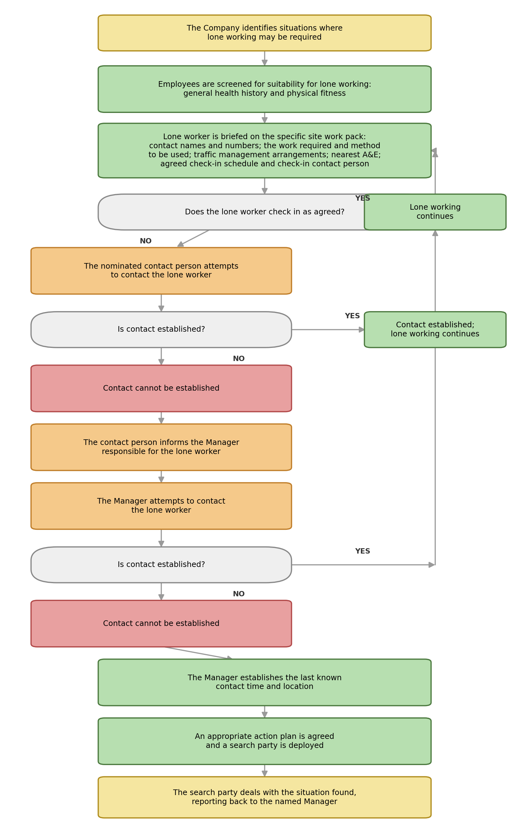
Process Summary:

The process is illustrated in the flowcharts above and summarised as follows: the Company identifies situations where lone working may be required; employees are screened for suitability (general health history and physical fitness); the lone worker is briefed on the specific site work pack, including contact names and numbers, the work required and method to be used, traffic management arrangements, the nearest A&E, and an agreed check-in schedule and contact person. If the lone worker checks in as agreed, lone working continues. If not, the nominated contact person attempts to make contact; if contact cannot be established, the contact person informs the manager responsible for the lone worker, who also attempts contact. If contact still cannot be established, the named manager establishes the last known contact time and location, an appropriate action plan is agreed, and a search party is deployed, dealing with the situation found with reference back to the named manager.

Authorisation & Responsibility:

The Manager responsible for the job decides whether a task is suitable for lone working, taking into account the restriction on climbing and aerial chainsaw operations above, and confirms the screening, briefing, check-in schedule and nominated contact person before the lone worker leaves. A Director retains overall responsibility for the effectiveness of this procedure.

Records:

Site work packs, check-in records and any escalation or search-party records are retained in line with the Documents, Data and Records Procedure.

Review:

This procedure is reviewed at least annually, or sooner following an incident, near miss, or change in legislation or guidance, to confirm that arrangements remain effective.

Document Control:

This procedure is communicated to relevant staff, reviewed at least annually or sooner following legislative change, incidents or significant operational changes, and approved by a director.

Signed
Name
Position | Director
Date

