COMPANY Ltd
Identification and Traceability Procedure

ISO9001 Requirements:

Under ISO 9001:2015, Clause 8.5.2 (Identification and Traceability) – the current version of the standard, which restructured and updated the equivalent 2008-edition clause 7.5.3 – the Company shall use suitable means to identify outputs (products and services) where necessary to ensure conformity.

The status of outputs with respect to monitoring and measurement requirements shall be identified throughout production and service provision.

Where traceability is a requirement (whether from a customer, a regulator, or the Company's own risk assessment), the Company shall control the unique identification of outputs and retain the documented information necessary to enable traceability.

National Highways Sector Scheme 18 (NHSS 18) – Natural Environment and Landscape – Requirements:

There must be an auditable process of document retention which can be clearly identified and traced.

The Company shall establish and maintain documented procedures to ensure that, where the origin of plants or seeds is required to be from a specific locality, written evidence of provenance is obtained prior to planting or sowing (see Series 3000 – Landscape and Ecology – of the Specification for Highway Works (SHW), and, where forest reproductive material is used, the Forest Reproductive Material (Great Britain) Regulations 2002, as amended).

Scope:

Orders, quotations, work in progress and completed work shall be identified and be traceable by one of the following methods:

- Job number
- Customer name
- Invoice number
- Certificate of Provenance if applicable

Where physical materials are used (for example planting stock, seed, treated timber, or chemicals requiring batch traceability), these shall be identified and traceable to their source – for example by delivery note, batch/lot number, or Certificate of Provenance – in line with the Inward Inspection of Purchased Items Procedure.

Objectives:

- There shall be a clearly identifiable trail throughout the lifecycle of contracts undertaken by the company
- Records relating to completed jobs shall be easily traceable

Process Owner:
NAME - ROLE

Legislative & Best Practice Framework:

In addition to the ISO 9001:2015 and NHSS 18 requirements set out above, this procedure has regard to the following. This list reflects the law and standards known to be current at the time this procedure was last reviewed and is not exhaustive:

• Forest Reproductive Material (Great Britain) Regulations 2002, as amended – provenance and marketing requirements for seed and planting stock of certain forest tree species
• Plant Health etc. (Forestry) Order 2005 (as amended) and related plant health legislation – biosecurity and traceability of plant material (see the Environmental & Sustainability Policy)
• UK GDPR and Data Protection Act 2018 – where a customer's name or other personal data forms part of the traceability record

Procedure:

- The customer’s name shall be included on contract documents
- A unique, sequential number shall be used for invoicing (the invoice shall also refer to the job number)
3. Records shall be filed in client files (filed alphabetically)
4. Where physical materials require traceability, the delivery note, batch/lot number or Certificate of Provenance is retained and cross-referenced to the job number.
5. Where seed or planting stock provenance is required, written evidence of provenance is obtained and retained before planting or sowing takes place.

Process Overview:
The process is illustrated in the flowchart below.

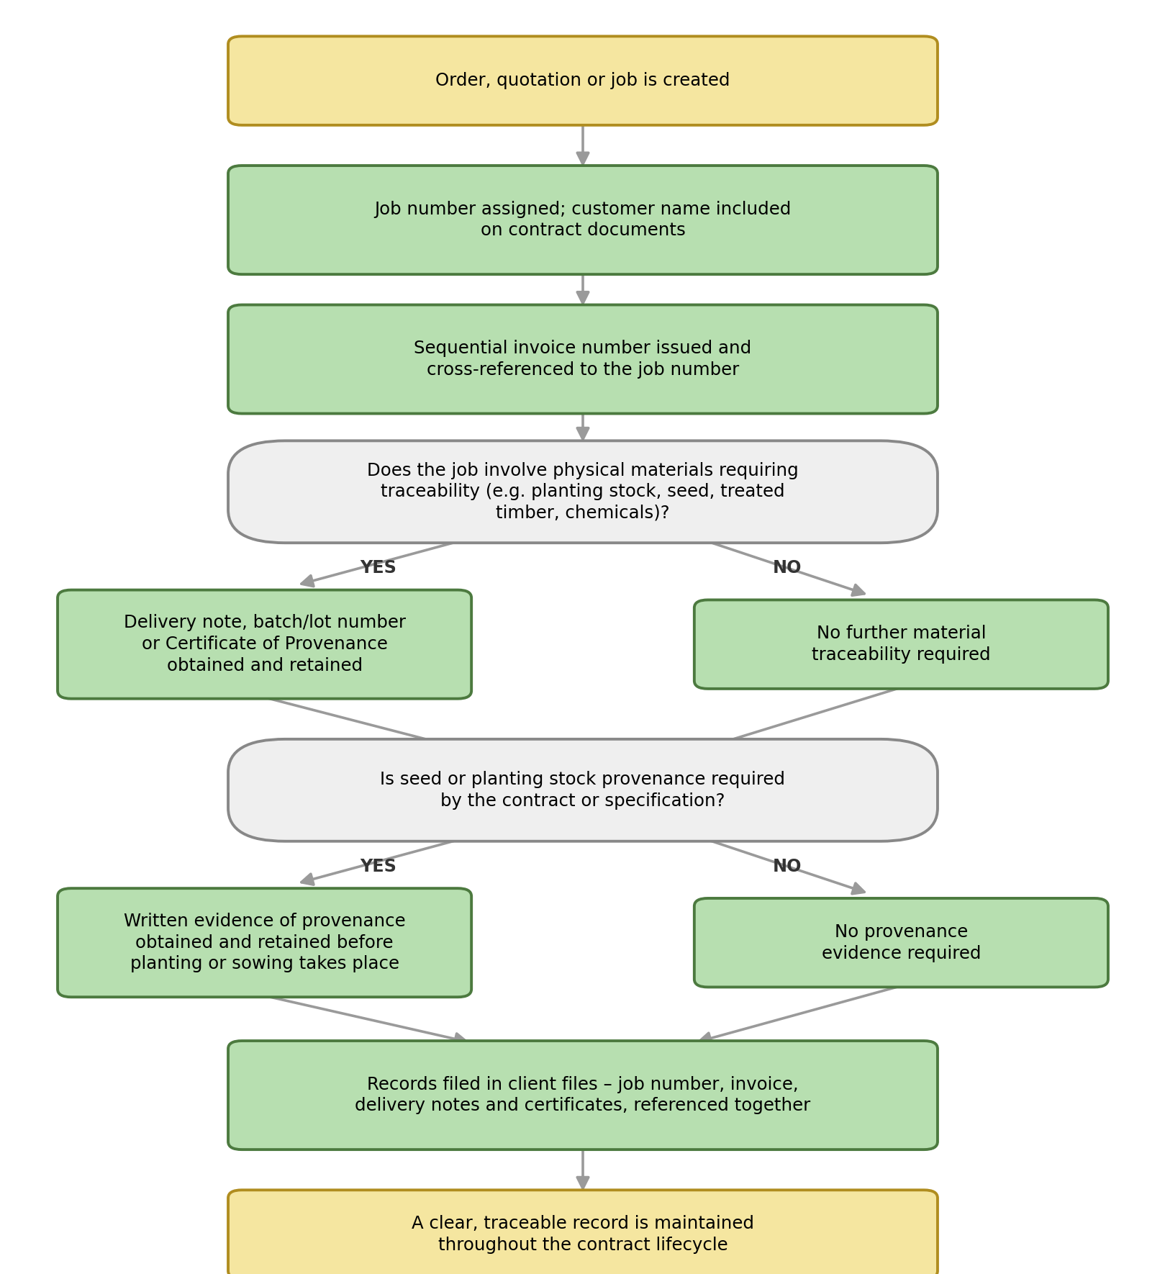

Authorisation & Responsibility:

The Process Owner is responsible for maintaining the job numbering and invoicing system and for confirming that records are filed and traceable. Team Leaders and site staff are responsible for obtaining and passing on delivery notes, batch information or Certificates of Provenance for any materials used on their jobs.

Records:

Job numbers, invoices, delivery notes, batch/lot information and Certificates of Provenance are retained in line with the Documents, Data and Records Procedure.

Review:

This procedure is reviewed at least annually, or sooner following a change in client, regulatory or certification (ISO 9001/NHSS 18) requirements, to confirm that the identification and traceability arrangements remain effective.

Document Control:

This procedure is communicated to relevant staff, reviewed at least annually or sooner following legislative change, incidents or significant operational changes, and approved by a director.

Signed
Name
Position | Director
Date

