Company Ltd
Incident Management Procedure
(Incorporating Non-Conformances, Corrective and Preventive Actions)

Scope:

This procedure shall be deemed to satisfy the requirements for a documented procedure for the control of non-conforming situations.

It shall be used when dealing with the following situations:

- Accidents and near misses
- Internal non-conformance
- Customer complaints
- Observations of opportunities for improvement
- Supplier non-conformance

Non-conformities shall be recorded, together with their disposition, to assist learning and to provide data for analysis and improvement activities.

Both service and support process non-conformities shall be recorded and controlled in order to provide valuable information for improving the effectiveness and efficiency of processes.

Review of non-conformities shall be conducted to determine if any trends or patterns of occurrence require attention.

Negative trends shall be considered for improvement both in the regular briefing meetings and as an input to management review where reduction goals and resource needs are considered.

The people carrying out the review shall have the competence to evaluate the total effects of the non-conformity and shall have the authority and resources to disposition the non-conformity and to define appropriate corrective and preventive action.

Corrective actions shall be appropriate to the effects of the non-conformities encountered.

The company shall take action to eliminate the causes of non-conformities in order to prevent recurrence.

The company shall also take action to eliminate the causes of potential non-conformities in order to prevent their occurrence.

Preventive actions shall be appropriate to the effects of the potential problems.

The effectiveness of corrective and preventive action shall be reviewed during management review meetings.

Objectives:

- All customer complaints are logged.
- All incidences of customer queries and complaints are dealt with consistently, promptly and appropriately.
- Supplier non-conformances are logged.
- Supplier non-conformances are dealt with consistently, promptly and appropriately.
- Trends are identified and discussed during management review meetings.
- The causes of non-conformance shall be identified and eliminated
- The causes of potential non-conformance shall be determined and eliminated

Legislative & Best Practice Framework:

This procedure has regard to the following legislation and guidance. This list reflects the law known to be current at the time this procedure was last reviewed and is not exhaustive:

- Health and Safety at Work etc. Act 1974
- Reporting of Injuries, Diseases and Dangerous Occurrences Regulations 2013 (RIDDOR) – work-related deaths and specified injuries must be reported to the HSE without delay, followed by a written report within 10 days; injuries causing incapacity for more than 7 days must be reported within 15 days; dangerous occurrences must be reported without delay. (The HSE opened a consultation on reforming RIDDOR in April 2026; the current Regulations remain in force and this procedure will be updated if and when any reform is confirmed.)
- Social Security (Claims and Payments) Regulations 1979 – duty to keep an accident book
- Management of Health and Safety at Work Regulations 1999 – review of risk assessments following an incident
- UK GDPR and Data Protection Act 2018 – handling of personal data within incident, complaint and investigation records

Responsibilities:

Responsibility | Named Individual | Position
Executive responsibility for health, safety, environmental interface, and quality management. | [DIRECTOR NAME] | Director
Responsibility for the supply and maintenance of information and guidance.  Ensuring day to day compliance with the procedure. | [NAME] | Director/Manager
Operational responsibility for health, safety, environmental interface, and quality management. |  | Team Leaders
Competent advice in respect of health and safety, environmental interface and quality management. | NAME | External Consultants

RIDDOR Reporting:

Where an incident meets the RIDDOR reporting threshold, the person with Executive responsibility (or their nominated Manager) makes the report to the HSE within the statutory timescale. Every incident logged is assessed against the RIDDOR criteria as part of the incident spreadsheet, whether or not it is ultimately reportable, so that the decision and its reasoning are recorded.

Process Owner:

NAME - ROLE

Process:

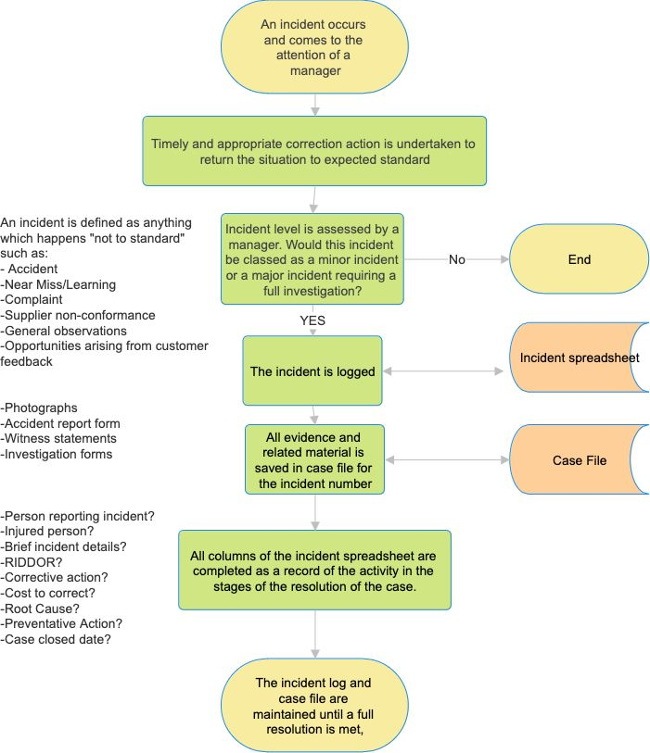
Process Summary:

The process is illustrated in the flowchart above and summarised as follows: an incident (an accident, near miss, complaint, or internal or supplier non-conformance, or an observation of an opportunity for improvement) comes to the attention of a Manager; timely and appropriate correction action is taken to return the situation to the expected standard; the Manager assesses whether it is a minor incident or a major incident requiring full investigation; if major, the incident is logged on the incident spreadsheet and a case file is opened, with evidence such as photographs, witness statements and investigation forms saved against the incident number; the spreadsheet is completed to record the person reporting, brief details, whether RIDDOR applies, corrective action, cost, root cause, preventive action and case closed date; and the log and case file are maintained until full resolution is reached.

Records:

The incident spreadsheet, case files, investigation forms, witness statements and any RIDDOR submission are retained in line with the Documents, Data and Records Procedure.

Review:

Trends and patterns in logged incidents are reviewed at regular briefing meetings and as part of management review, where reduction goals and resource needs are considered. This procedure itself is reviewed at least annually, or sooner following a significant incident, a RIDDOR-reportable event, an audit finding, or a change in legislation, to confirm that arrangements remain effective.

Document Control:

This procedure is communicated to relevant staff, reviewed at least annually or sooner following legislative change, incidents or significant operational changes, and approved by a director.

Signed
Name
Position | Director
Date

