Company Ltd
Internal Audit Procedure

Scope:

This procedure shall apply to all documented procedures operated by the company.

Internal audits shall include site checks.

A schedule for site checks shall be included on the internal audit planning matrix. At least two site checks shall be undertaken in every 12-month period.

In addition to site checks, each documented procedure shall be subject to internal audit at least once every 12 months, on a risk-based and priority basis, so that over a rolling cycle every part of the management system is reviewed.

Internal audits shall be carried out impartially. An internal auditor shall not audit their own work or an area for which they are the Process Owner, in line with the principles of ISO 19011.

The status and importance of activities and the findings previous audit shall be considered when planning the ongoing audit schedule.

Objectives:

- To ensure that practice is kept in line with the documented procedure or;
- To enable the evolution of practice and a new procedure to be documented

Legislative & Best Practice Framework:

This procedure has regard to the following standards and guidance. This list reflects what is known to be current at the time this procedure was last reviewed and is not exhaustive:

- ISO 9001:2015, Clause 9.2 (Internal Audit) – requirement to conduct internal audits at planned intervals to determine conformity and effectiveness
- ISO 14001:2015 and ISO 45001:2018, Clause 9.2 (where the Company operates to these standards) – equivalent internal audit requirements for environmental and health and safety management
- ISO 19011:2018 (third edition) – Guidelines for auditing management systems, including the principles of auditor impartiality, evidence-based conclusions and audit programme management
- SSIP Core Criteria, Constructionline Common Assessment Standard and the Arboricultural Association Approved Contractor standard – all expect evidence of a functioning internal audit programme

Process Owner:

NAME - ROLE

Process:

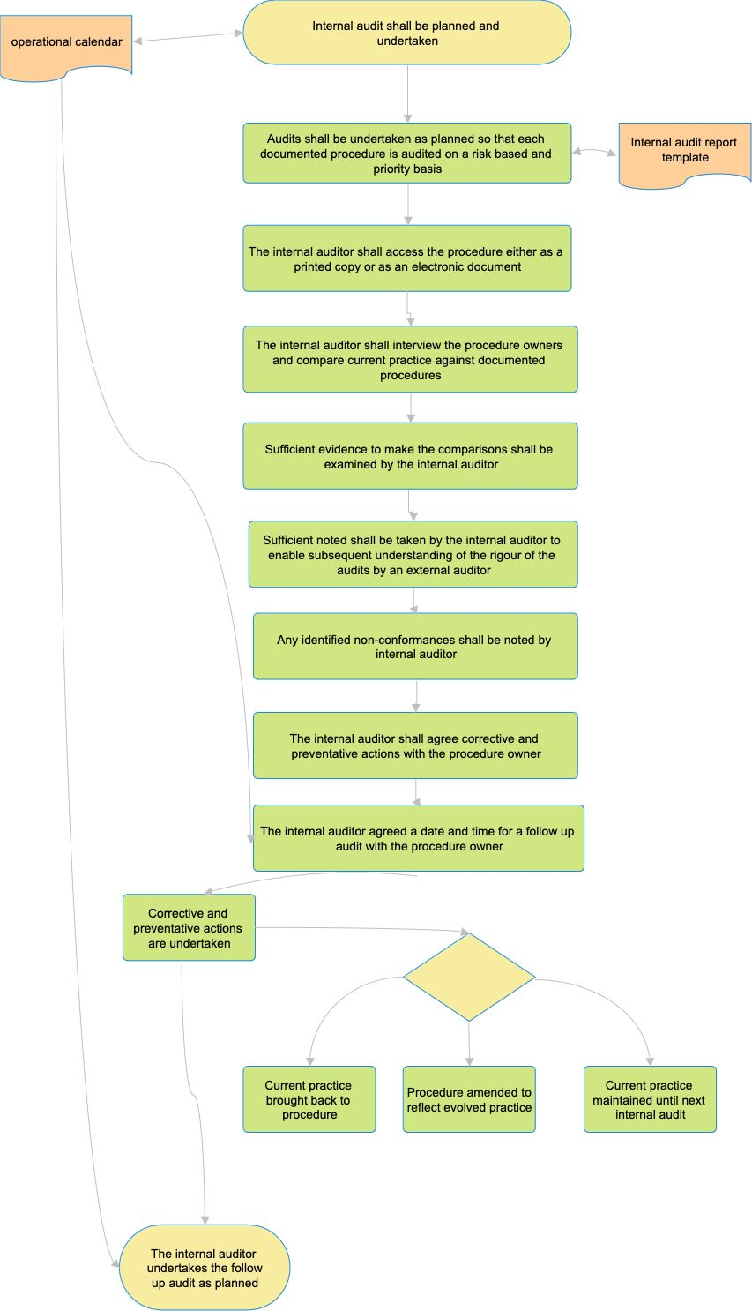
Process Summary:

The process is illustrated in the flowchart above and summarised as follows: internal audits are planned against the operational calendar and undertaken so that each documented procedure is audited on a risk-based and priority basis; the internal auditor accesses the procedure (printed or electronic), interviews the procedure owner, and compares current practice against the documented procedure, examining sufficient evidence to support the comparison; sufficient notes are taken to allow an external auditor to subsequently understand the rigour of the audit; any non-conformances are noted, and the internal auditor agrees corrective and preventive actions, and a follow-up date, with the procedure owner; findings and actions are recorded on the internal audit report template; corrective and preventive actions are then undertaken, resulting in either current practice being brought back into line with the procedure, the procedure being amended to reflect evolved practice, or current practice being maintained until the next internal audit; and the internal auditor undertakes the follow-up audit as planned.

Records:

Completed internal audit reports, the audit planning matrix/operational calendar entries, and evidence of corrective and preventive actions are retained in line with the Documents, Data and Records Procedure.

Review:

The audit programme and schedule are reviewed on an ongoing basis, taking into account the status and importance of activities and the findings of previous audits. This procedure itself is reviewed at least annually, or sooner following a significant audit finding, a change in certification requirements, or a change in the Company's activities, to confirm that arrangements remain effective.

Document Control:

This procedure is communicated to relevant staff, reviewed at least annually or sooner following legislative or standards change, incidents or significant operational changes, and approved by a director.

Signed
Name
Position | Director
Date

