Company Ltd
Work Equipment Inspection and Use Procedure

Scope:

This procedure shall apply to the inspection and use of relevant work equipment throughout the organisation.

Objectives:

- To ensure that all significant items of work equipment are checked against defined criteria
- To ensure that all significant items of work equipment are checked to an agreed schedule
- To ensure that all significant items of work equipment are deployed in a well maintained and fit for purpose condition.
- To ensure that work equipment is only used by competent operators

Legislative & Best Practice Framework:

This procedure has regard to the following legislation and guidance. This list reflects the law known to be current at the time this procedure was last reviewed and is not exhaustive:

- Provision and Use of Work Equipment Regulations 1998 (PUWER) – the core requirement that work equipment is suitable, maintained in a safe condition, inspected at suitable intervals by a competent person, and used only by trained and competent operators
- Lifting Operations and Lifting Equipment Regulations 1998 (LOLER) – additional requirements for lifting equipment (for example MEWPs and rigging equipment); see the specific procedures referenced below
- Electricity at Work Regulations 1989 – additional requirements for electrical equipment; see the specific procedure referenced below
- Health and Safety at Work etc. Act 1974 – general duty to provide equipment that is safe and without risk to health
- HSE Approved Code of Practice L22 (Safe use of work equipment) and current AFAG/HSE guidance relevant to arboricultural equipment

Process Owner:

NAME - ROLE

Typical Work Equipment and Inspection Frequencies:

Significant work equipment is listed on the Equipment Register and would normally include:

- Woodchippers
- Stump grinders
- Trailers
- Chainsaws
- Hedge trimmers
- Mobile Elevating Work Platforms (MEWP)

Weekly recorded checks apply to:

- Chippers
- Stump grinders
- Trailers
- MEWP
Chainsaws and other powered hand tools are maintained daily after use by competent operators; these routine maintenance events are not formally recorded. All powered hand tools are subject to random, unannounced inspection via site audits by a manager, and these checks are recorded on site audit forms.

Vehicles, lifting equipment, ladders, electrical equipment and measuring equipment are subject to their own specific procedures (see the Measuring and Monitoring (Calibration) Procedure and related procedures) rather than this general work equipment process.

See below for the flowchart.

Process:

(See over…)

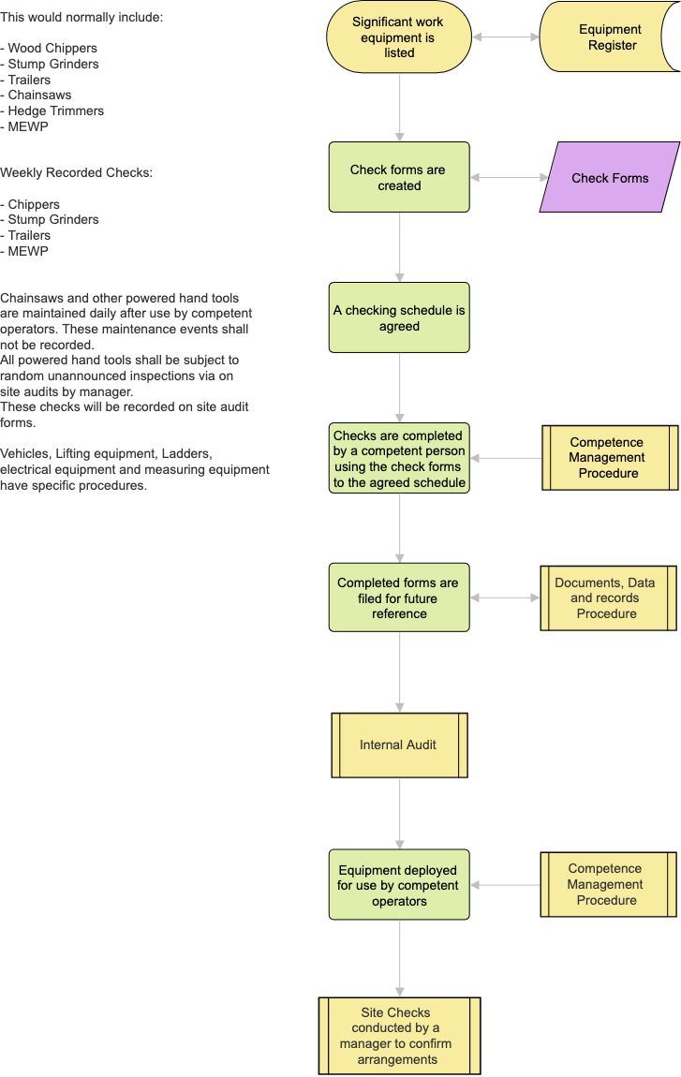
Process Summary:

The process is illustrated in the flowchart above and summarised as follows: significant work equipment is listed on the Equipment Register; check forms are created for the agreed checking schedule; checks are completed by a competent person (see the Competence Management Procedure) using the check forms to the agreed schedule; completed forms are filed for future reference (see the Documents, Data and Records Procedure); findings feed into the internal audit programme (see the Internal Audit Procedure); equipment is deployed for use only by competent operators; and site checks are conducted by a Manager to confirm that arrangements are being followed in practice.

Records:

Completed check forms, the Equipment Register, and site audit records are retained in line with the Documents, Data and Records Procedure.

Review:

The Equipment Register and checking schedule are reviewed to reflect the equipment actually in use. This procedure itself is reviewed at least annually, or sooner following an equipment failure, an audit finding, or a change in legislation, to confirm that arrangements remain effective.

Document Control:

This procedure is communicated to relevant staff, reviewed at least annually or sooner following legislative change, incidents or significant operational changes, and approved by a director.

Signed
Name
Position | Director
Date

