Company Ltd
Environmental Aspects and Impacts Register Procedure

Scope:

This procedure describes the process of:

• Identification of the environmental aspects inherent in the activities and
services of the company and within the defined scope of the
environmental management system

• Determination of those aspects that have or can have significant
impact(s) on the environment

The company shall ensure that the significant environmental aspects are
considered in maintaining the environmental management system.

Objectives:
• To ensure that all significant environmental aspects are identified

• To ensure that the impacts arising from the significant aspects are
Identified

• To ensure that all significant impacts are controlled and reduced

• To ensure that environmental performance is discussed at
management review meetings

Process Owner:

NAME - ROLE

Process:
The process is illustrated in the flowchart below and summarised as follows:

1. The activities the Company undertakes are listed, and each is evaluated to determine the significance of its environmental aspects, using the Significance Scale set out in the Aspects and Impacts Register.

2. Aspects assessed as significant are added to the Aspects and Impacts Register, and the environmental impacts arising from each are investigated and also added to the Register.

3. A decision is made as to which impacts are significant; significant impacts are highlighted (coloured red) on the Register.

4. The significance of each significant impact is evaluated and the result recorded on the Register.

5. Control measures are put in place to reduce the significance of each significant impact, and these are recorded on the Register. Specific procedures are documented where required.

6. Results, and any further plans arising, are discussed at management review meetings and considered as part of the Company's internal audit programme.

7. Any non-conformance identified (through internal audit, management review, incident or complaint) is addressed through corrective and preventive action, which is recorded and, where it changes the Company's assessment of an aspect or impact, fed back into the Register.

Authorisation & Responsibility:

Aspects and impacts are identified and assessed by the Process Owner (or a competent person nominated by the Process Owner). Significance ratings, and the control measures recorded against significant impacts, are reviewed and formally authorised by a Director before being relied upon. Additions or changes to the Aspects and Impacts Register are only made following this authorisation.

Communication:

Significant aspects, impacts and the control measures adopted are communicated to staff through induction, toolbox talks and supervisor briefings, in line with the Environmental & Sustainability Policy. Where a significant aspect or impact is specific to a site or task, the relevant control measures are incorporated into the Method Statement and/or Site-Specific Risk Assessment for that job, so that they are communicated to the team, and to any sub-contractor engaged on the Company's behalf, before work commences.

Records:

The Aspects and Impacts Register itself is the primary record of aspects, impacts, significance and controls. Briefings on significant aspects and controls are recorded (for example within induction records, toolbox talk registers, or job files) and retained in line with the Documents, Data and Records Procedure. Records of internal audits, management review and any corrective/preventive action are similarly retained.

Review:

The Aspects and Impacts Register is reviewed at least annually, alongside the Environmental & Sustainability Policy, and whenever a new activity, service or significant change to operations is introduced. The effectiveness of this procedure itself is reviewed by the Process Owner/Director at least annually, and following any relevant internal audit finding, non-conformance, incident or management review outcome, to confirm that significant aspects continue to be identified and controlled effectively.

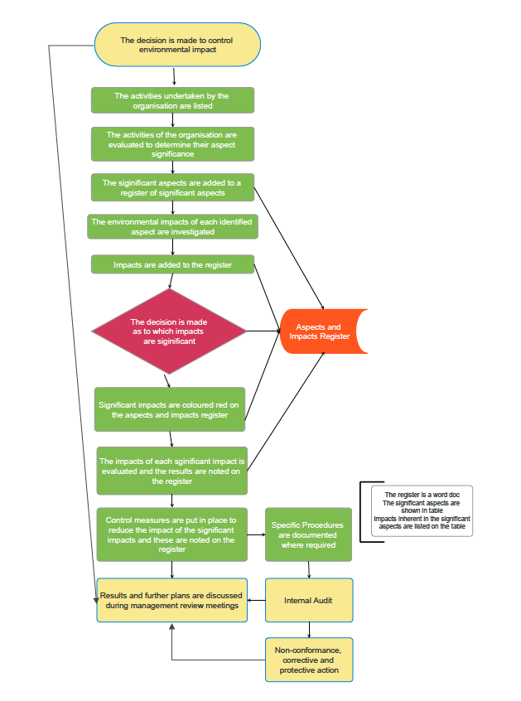
Document Control:

This procedure is communicated to relevant staff, reviewed at least annually or sooner following legislative change, incidents or significant operational changes, and approved by a Director.

Signed
Name
Position | Director
Date

