COMPANY
Risk Assessment Procedure

Scope:

This procedure shall apply to all company undertakings.

Objectives:

- Works are planned and approved following the logical sequence of events.
- All risks shall be assessed prior to undertaking work.
- Control measures shall be put in place to ensure that the level of risk is as low as reasonably practicable.
- The identification of hazard and the subsequent control of evaluated risk shall ensure compliance with company policy

Process Owner:

NAME - ROLE

Authorisation & Responsibility for Risk Assessments:

Generic Risk Assessments (GRAs) are compiled by the Process Owner (or a competent person nominated by the Process Owner) and are reviewed and formally authorised by a director before being adopted into the Company's GRA library and made available for use.

Site-Specific Risk Assessments are compiled by the Surveyor at the survey stage and by the Team Leader on the day of the works (to record any additional site-specific hazard) and are authorised for work to proceed through the Client Review and Client Approval Received stages shown in the Sequence of Events, and by the Team Leader's confirmation prior to work starting on site.

Sequence of Events:

See page 2 for the flowchart…

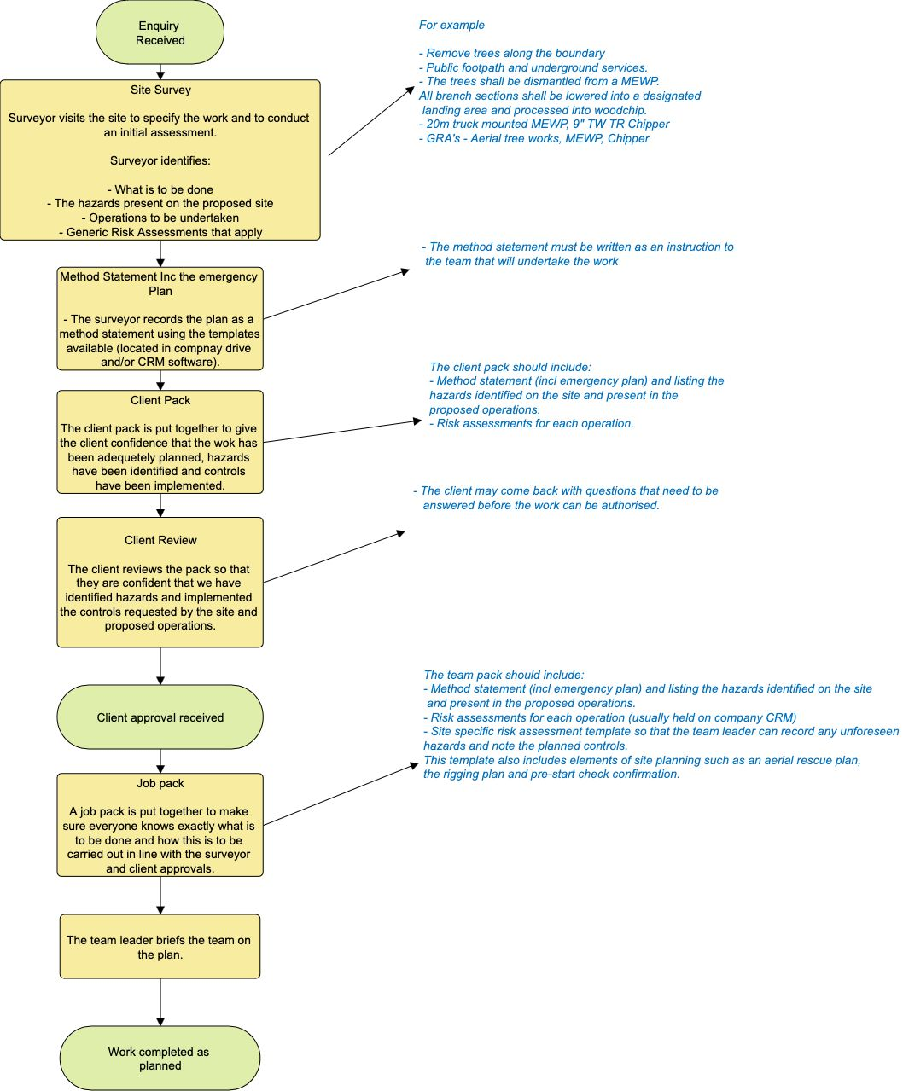
Generic Risk Assessment:

Generic risk assessments are prepared for all operations, hazards and risks that tend to be the same on every site.

These documents will identify the hazard, identify who may be harmed and how, evaluate the risk and specify the standard operation procedures to be used to reduce the risk to a level which is acceptable and as low as reasonably practicable.

The following 4x4 matrix shall be used to evaluate the level of risk before and after control.

 | Trivial  Incident | Minor  Incident | Major Incidents | Death
Improbable | 2 | 4 | 6 | 8
Possible | 4 | 6 | 8 | 10
Occasional | 6 | 8 | 10 | 12
Regular | 8 | 10 | 12 | 14

For simplicity, descriptors of severity were chosen reflecting physical harm to persons but it should be noted that these severity ratings may also apply to many categories of harm; harm to the environment or reputation for example.

When allotting scores to the intersection of likelihood x severity, improbable was considered first of all and a score of 2 was given to show the significance of an improbable trivial event. A score of 4 was given to an improbable minor event to acknowledge that although the event was improbable, a minor was worse than a trivial and so forth.

This process was repeated for each category. Where more than one intersection bears the same significance rating, the assumption is that each factor, although different, would be equally undesirable. For example, a regular minor incident has equal undesirability to an occasional major incident.

Process:

This process describes the development of our generic risk assessments.

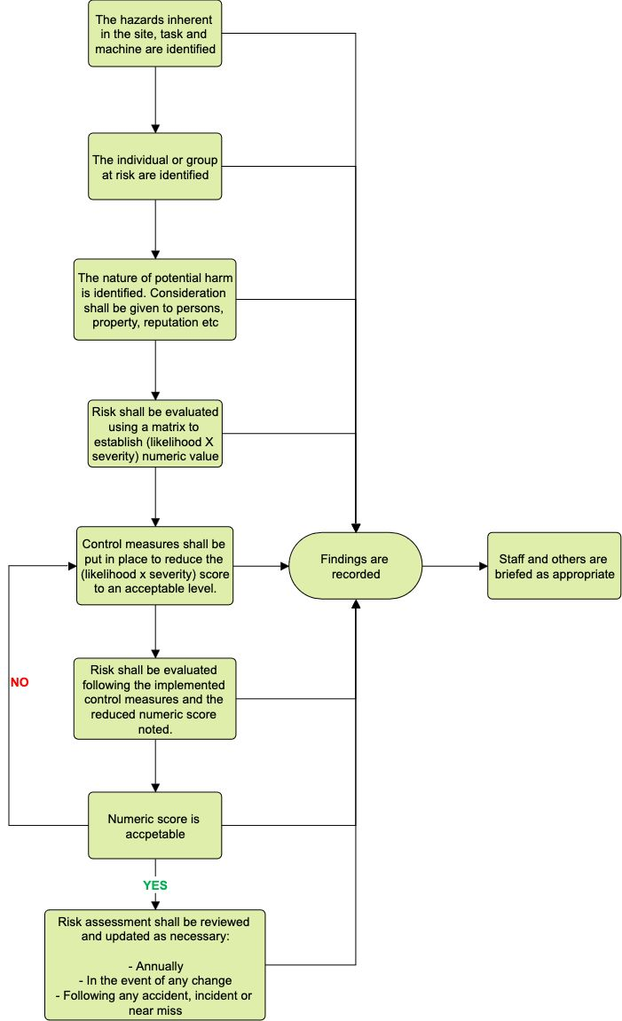

Specific Risk Assessment:

Specific risks arising from specific situations, the site, the task or the machine in use are noted on a daily risk assessment template.

The template is completed in stages from taking the initial enquiry, through the work survey and upon arrival at the site prior to the start of work. The risk assessment shall be updated if any site factor or aspect of the work plan changes.

The following diagram shows the sequence of events, working from left to right, from initial information capture through planning the operation to completion of the task.

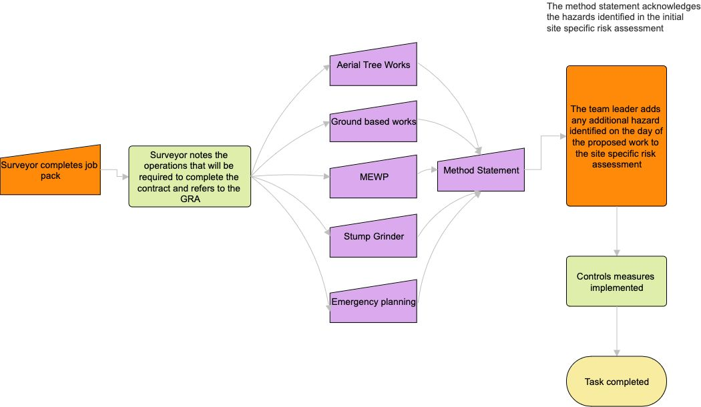

The generic risk assessments shown in mauve in the diagram have been included for example purposes. The company maintains a comprehensive suite of generic risk assessments covering all of the operations undertaken.

Method Statements and Risk Assessments:

Where a Method Statement is produced for a job, it incorporates the hazards, controls and standard operating procedures identified within the applicable Generic Risk Assessment(s) and the Site-Specific Risk Assessment, as shown in the Sequence of Events above. Method Statements are written as an instruction to the team undertaking the work and reference the relevant GRA(s) by name; a Method Statement is not issued for work to proceed unless the applicable risk assessments have first been completed and reviewed.

Communication of Risk Assessments:

Risk assessments are communicated as follows:

- Staff and sub-contractors: the Team Leader briefs the team on the Method Statement, emergency plan and applicable risk assessments (including any additional hazards identified on the day) before work starts on site, as shown in the Sequence of Events. Sub-contractors engaged to work alongside or on behalf of the Company are provided with the relevant Method Statement and risk assessments as part of the Job Pack and are included in the Team Leader's briefing.
- Clients: relevant risk assessments are issued to the client within the Client Pack for review, and client approval is obtained before work proceeds, as shown in the Sequence of Events.
- Any subsequent change to the task, site conditions or personnel is re-briefed to those affected before work continues.

Records of Briefings:

Team Leader briefings are recorded (for example, by way of a signed briefing/toolbox talk record or equivalent site record confirming attendance and understanding) and retained in line with the Documents, Data and Records Procedure. Client review and approval of the Client Pack is similarly retained within the job file as evidence that risk assessments were communicated and accepted prior to work commencing.

Review of this Procedure:

In addition to the review of individual risk assessments described above, the effectiveness of these risk assessment arrangements as a whole is reviewed by the Process Owner/Director at least annually, and following any significant incident, near miss, audit finding or client feedback. This review considers whether hazards are being consistently identified, whether control measures are proving effective in practice, and whether the process itself (including communication, authorisation and record-keeping arrangements) remains fit for purpose. Any resulting changes are updated within this procedure and communicated to those affected.

Document Control:

This procedure is communicated to relevant staff, reviewed at least annually or sooner following legislative change, incidents or significant operational changes, and approved by a director.

Signed
Name
Position | Director
Date

