COMPANY
Supplier & Subcontractor Evaluation, Approval and Monitoring Procedure
1. Purpose
This procedure explains how [COMPANY NAME] selects, evaluates, approves, monitors, re-evaluates and, where necessary, suspends or removes suppliers, subcontractors and other external service providers. The purpose is to ensure that externally provided products, services and specialist activities consistently meet the company's quality, safety, environmental, legal, contractual and ethical requirements.
The procedure is intended to provide clear, auditable evidence of how the company controls its supply chain and subcontracted activities. It supports the company Quality Management System and may be used as evidence during Constructionline Gold, Common Assessment Standard, client, principal contractor and other third-party audits.
2. Scope
This procedure applies to all external organisations and individuals whose products or services can affect the quality, safety, environmental performance, legal compliance or delivery of the company's work. This includes, where relevant:
- Arboricultural and vegetation management subcontractors.
- Plant, MEWP, crane and specialist lifting providers.
- Traffic management contractors.
- Ecologists, arboricultural consultants and other technical specialists.
- LOLER examiners, equipment inspectors and maintenance/service providers.
- Waste carriers and disposal/recycling providers.
- Timber, fuel, equipment, PPE and consumable suppliers.
- Training providers and occupational competence assessors.
- Labour providers and agency personnel.
- IT, data, document storage and other business-critical service providers.
- Any other supplier or subcontractor whose failure could materially affect contractual delivery or compliance.
Low-risk routine purchases may be subject to simplified controls, but critical or high-risk suppliers and subcontractors must undergo enhanced pre-qualification and monitoring.
3. Definitions
Supplier: An organisation providing goods, materials, equipment or routine services.
Subcontractor: An organisation or self-employed person engaged to perform part of the company's contracted work or a specialist activity on the company's behalf.
External provider: Collective term for suppliers, subcontractors, consultants and outsourced service providers.
Critical supplier / subcontractor: An external provider whose failure could significantly affect safety, legal compliance, client requirements, quality, programme, environmental performance or company reputation.
Approved Supplier & Subcontractor Register (ASSR): The controlled record showing providers that are approved, conditionally approved, suspended or removed.
Non-conformance: A failure to meet a specified, contractual, statutory, quality, safety, environmental or company requirement.
4. Roles and Responsibilities
Directors
- Have ultimate responsibility for the effectiveness of this procedure and supply-chain governance.
- Approve high-risk or exceptional providers where required.
- Review significant supplier failures, suspensions and removals.
- Ensure adequate resources are available for supplier evaluation and monitoring.
Managers
- Ensure suppliers and subcontractors are assessed before use.
- Determine provider risk classification.
- Verify required documentation and maintain the Approved Supplier & Subcontractor Register.
- Monitor performance and ensure non-conformances are investigated and closed out.
- Escalate significant concerns to a director.
Team Leaders
- Check that only approved providers are used on site where applicable.
- Monitor subcontractor behaviour, workmanship, quality, safety and environmental performance.
- Report defects, delays, unsafe practices, complaints or other concerns promptly.
- Confirm site-specific requirements have been communicated before work starts.
Employees / Buyers / Administrators
- Use approved providers wherever required.
- Obtain and retain specified evidence before placing orders or engaging services.
- Report concerns, delivery failures, defects or expired documents.
- Do not bypass approval controls without authorised exception.
5. Supplier and Subcontractor Risk Classification
The level of evaluation and monitoring must be proportionate to the risk presented by the provider. The following classification should be used as a guide:
Risk level | Typical examples | Minimum controls | Review frequency
Low | Office supplies, standard consumables | Basic supplier details, product suitability, delivery/performance review | As needed / annual register review
Medium | Plant hire, equipment servicing, waste providers, training providers | Document checks, competence/insurance where relevant, performance monitoring | At least annually
High / Critical | Tree-work subcontractors, MEWP/crane providers, traffic management, specialist consultants, labour providers | Full pre-qualification, competence and insurance verification, site monitoring, enhanced due diligence, documented annual re-evaluation | Before first use and at least annually
6. Initial Evaluation and Approval
Before first use, the responsible Manager must ensure the provider has been evaluated to a level appropriate to its risk. Approval must be based on evidence, not price alone.
6.1 Product Suppliers
- Product conformity with specification and intended use.
- Quality and reliability of products supplied.
- Availability, lead times and continuity of supply.
- Past performance and defect history.
- Price, discount and overall value for money.
- Stock holding and ability to meet programme requirements.
- Relevant product certification, warranties or declarations where required.
- Safety and environmental management arrangements where relevant.
- Ethical, legal and reputational considerations.
- Relevant recognised certification, where held, may be considered as supporting evidence but is not an automatic condition of approval.
6.2 Service Providers and Subcontractors
Service providers and subcontractors must be assessed using a supplier/subcontractor evaluation questionnaire or equivalent documented pre-qualification record. Evidence should be proportionate to the work and may include:
- Company identity, trading status and contact details.
- Relevant experience, references and evidence of similar work.
- Current Employers' Liability, Public Liability and, where relevant, Professional Indemnity insurance.
- Competence records, qualifications, cards, licences and task-specific training.
- For arboricultural activities, relevant NPTC/LANTRA or equivalent competence evidence where applicable.
- Health and safety policy/arrangements and recent performance where proportionate.
- Environmental arrangements, waste carrier registration and permits where applicable.
- Quality management arrangements and relevant certification where held.
- Plant/equipment inspection, maintenance and statutory examination records where applicable.
- Accident, enforcement, complaint or significant non-conformance history where relevant.
- Modern Slavery, ethical labour and right-to-work controls where labour is supplied.
- Anti-bribery, competition law and ethical conduct expectations where relevant.
- Data protection and information-security controls where the provider handles personal, client or commercially sensitive information.
- Ability to meet contract-specific requirements, specifications, programme and reporting obligations.
7. Approval Status and the Approved Supplier & Subcontractor Register
Following evaluation, each provider must be assigned a clear status on the Approved Supplier & Subcontractor Register:
- Approved - all required checks completed and suitable for use.
- Conditionally Approved - limited use permitted subject to stated conditions or outstanding evidence.
- Suspended - temporarily prohibited from new work pending investigation or corrective action.
- Removed / Not Approved - not permitted for use unless formally re-evaluated and re-approved.
The register should record, as applicable, provider name, service/category, risk level, approval status, approval date, reviewer, insurance expiry dates, competence/certification expiry dates, last performance review, next review date and any restrictions or conditions.
8. Communication of Requirements Before Work or Supply
The company must ensure that external providers understand what is required before products are ordered or services commence. Purchase orders, subcontract orders, scopes of work, specifications, RAMS requirements or other instructions should identify relevant requirements, including where applicable:
- Technical or product specification.
- Required standards, drawings, work instructions or client requirements.
- Delivery dates, programme and access arrangements.
- Competence and supervision requirements.
- Quality inspection, testing, handover or reporting requirements.
- Health, safety and environmental controls.
- Site rules, permits and welfare arrangements.
- Waste, biosecurity or ecological requirements.
- Confidentiality, data protection or information-security requirements.
Requirement to notify [COMPANY NAME] before making material changes to personnel, process, product, equipment or subcontracting arrangements.
9. Verification Before Mobilisation
For higher-risk or subcontracted operational work, the responsible Manager or Team Leader must verify that required pre-start evidence remains current before mobilisation. Expired or missing critical evidence must be resolved before work starts unless a director authorises a documented exceptional arrangement.
- Insurance certificates.
- Competence and training records.
- Plant inspection, maintenance and statutory examination records.
- RAMS and task-specific documentation.
- Licences, registrations and permits.
- Named personnel and supervision arrangements.
- Any contract-specific approvals required by the client or principal contractor.
10. Ongoing Performance Monitoring
Approval is not permanent. Provider performance must be monitored throughout the relationship using evidence appropriate to the service or product supplied.
- Quality of products, workmanship and service.
- Conformity with specification and contract requirements.
- Delivery and programme performance.
- Defects, rework, returns and warranty issues.
- Site inspections and supervisor/Team Leader feedback.
- Customer complaints or compliments.
- Health and safety performance, incidents and unsafe behaviours.
- Environmental performance, waste control and pollution/biosecurity issues.
- Communication, responsiveness and cooperation.
- Accuracy of invoices, records, reports and supporting documentation.
- Performance against corrective actions or agreed improvement plans.
Significant positive or negative performance information should be recorded against the provider so that future purchasing and subcontracting decisions are evidence-based.
11. Annual Re-evaluation
All medium and high/critical providers should be formally re-evaluated at least annually, and sooner where performance, scope, ownership, certification, insurance, legislation or contract requirements materially change. Low-risk suppliers may be reviewed through an annual register review or purchasing-performance review.
The annual review should consider:
- Validity of insurance, competence, licences and certifications.
- Defects, returns, rework and non-conformances.
- Complaints and customer feedback.
- Delivery and programme reliability.
- Site inspection and management feedback.
- Accidents, incidents or enforcement issues.
- Environmental or ethical concerns.
- Changes to scope, ownership, key personnel or delivery arrangements.
- Overall value and continued suitability.
The review outcome must be documented and the provider status confirmed, restricted, suspended or removed as appropriate.
12. Expiring Document Controls
Where approval depends on time-limited evidence, expiry dates must be recorded and monitored. Providers must be asked for renewed evidence before expiry wherever practicable. Critical evidence must not be allowed to lapse unnoticed.
- Employers' and Public Liability insurance.
- Professional Indemnity insurance where applicable.
- Operator competence or licence evidence.
- Trade or waste registrations.
- LOLER, inspection or calibration evidence where relevant.
- Accreditation/certification relied upon as part of approval.
13. Supplier / Subcontractor Non-Conformance and Corrective Action
Where an external provider fails to meet requirements, the issue must be controlled proportionately to its seriousness and risk.
- Identify and record the non-conformance, defect, delay, incident or complaint.
- Take immediate action to protect people, the environment, the client and the quality of the work/product.
- Notify the provider and relevant internal Manager.
- Determine whether supplied goods, completed work or current activities need to be stopped, quarantined, rejected, corrected or reworked.
- Investigate the root cause where the issue is significant, repeated or systemic.
- Agree corrective actions, responsible persons and target dates.
- Verify that corrective action has been completed and is effective.
- Update the provider performance record and approval status where necessary.
- Escalate serious or repeated issues to a director.
14. Suspension and Removal
A provider may be suspended or removed from the Approved Supplier & Subcontractor Register where there is unacceptable risk or repeated poor performance. Reasons may include:
- Serious safety, environmental, quality or ethical breach.
- Use of unapproved or incompetent personnel.
- Failure to maintain required insurance, licences or statutory approvals.
- Repeated defects, rework, complaints or delivery failures.
- Failure to implement agreed corrective actions.
- Falsification or deliberate misrepresentation of records.
- Bribery, fraud, collusion, Modern Slavery concerns or other serious misconduct.
- Client or regulatory prohibition.
Suspension or removal decisions, reasons and any conditions for re-approval must be documented. Re-approval requires evidence that the relevant concerns have been satisfactorily resolved.
15. Emergency and One-off Suppliers
Where an urgent operational need makes it impracticable to complete the normal approval process before use, an unapproved provider may only be used where authorised by a manager or Director. The decision must be documented, critical legal/safety/competence checks must still be completed, and the provider must be fully evaluated afterwards if future use is likely.
Emergency use must never be used to bypass mandatory legal, competence, insurance or client requirements.
16. Ethical Procurement, Modern Slavery and Anti-Bribery
[COMPANY NAME] expects suppliers and subcontractors to conduct business lawfully and ethically. Higher-risk providers should be assessed proportionately for labour, recruitment and ethical supply-chain risks.
- No forced, bonded, trafficked or involuntary labour.
- No retention of workers' identity documents as a means of coercion.
- No unlawful recruitment fees or deductions.
- Compliance with applicable right-to-work and employment requirements.
- No bribery, kickbacks, facilitation payments or improper inducements.
- No collusive tendering, price-fixing, market sharing or improper exchange of competitively sensitive information.
- Prompt reporting of suspected serious ethical or legal breaches.
Where concerns are identified, the company will investigate, seek corrective action where appropriate, and suspend or terminate the relationship where the risk cannot be satisfactorily controlled.
17. Environmental and Sustainability Considerations
Environmental performance should be considered where relevant to the goods or services being purchased. This may include waste management, pollution prevention, legal compliance, timber/product sourcing, fuel use, recycling, biosecurity and the provider's ability to meet project-specific environmental requirements.
ISO 14001 or other recognised certification may be accepted as supporting evidence where relevant, but certification does not replace the company's responsibility to assess actual suitability and performance.
18. Records and Retention
Records must be sufficient to demonstrate that external providers have been appropriately selected, controlled and monitored. Records should be retained in accordance with the company's document-retention arrangements and contractual/legal requirements.
- Completed evaluation / pre-qualification questionnaires.
- Insurance certificates and competence evidence.
- Licences, registrations and certifications.
- Approved Supplier & Subcontractor Register.
- References and due-diligence records where used.
- Performance reviews and annual re-evaluations.
- Site inspection or monitoring records.
- Complaints, defects and non-conformance records.
- Corrective actions and evidence of close-out.
- Suspension/removal decisions and re-approval evidence.
- Emergency supplier approvals.
19. Management Review and Continual Improvement
Supplier and subcontractor performance is reviewed as part of management review and operational meetings. Trends, significant incidents, recurring defects, complaints, overdue corrective actions, suspended providers and improvement opportunities should be considered.
Findings may lead to changes in approval criteria, preferred suppliers, contract controls, training, purchasing arrangements, supplier development actions or this procedure.
20. Audit Evidence Matrix
Audit expectation | Primary evidence | Responsible record owner
Defined supplier/subcontractor selection criteria | This procedure; completed evaluation questionnaire; competence/insurance evidence | Manager / Administrator
Approved provider control | Approved Supplier & Subcontractor Register | Manager / Administrator
Subcontractor monitoring | Site inspections; Team Leader feedback; performance review records | Manager / Team Leader
Quality performance monitoring | Defect, complaint, rework and KPI records | Manager
Corrective action | Supplier non-conformance / corrective-action records | Manager
Periodic review | Annual provider re-evaluation; management review minutes | Director / Manager
Workforce communication | Induction, briefings, purchasing/site instructions | Manager / Team Leader
Document control | Version-controlled procedure and review record | Document owner
Appendix A - Suggested Evaluation Scoring Matrix
The following scoring matrix may be used for medium and high/critical providers. It can be adapted to suit the company and contract. A low score in a critical legal or safety category must not be offset by a high commercial score.
Criterion | Weight | Score 1 | Score 3 | Score 5
Technical competence / capability | High | Unproven / unsuitable | Adequate evidence | Strong, verified capability
Insurance / legal compliance | Critical | Missing / unacceptable | Adequate | Fully compliant and current
Quality performance | High | Poor / repeated defects | Acceptable | Consistently strong
H&S performance | Critical | Serious concerns | Acceptable | Strong controls and record
Environmental performance | Medium | Concerns / non-compliance | Adequate | Strong relevant controls
Delivery / responsiveness | Medium | Unreliable | Generally reliable | Consistently reliable
Ethical / labour controls | High where relevant | Material concerns | Adequate | Strong verified controls
Commercial value | Medium | Poor value | Acceptable | Strong value and transparency

Appendix B - Supplier / Subcontractor Review Record
Provider name | [COMPLETE]
Category / service | [COMPLETE]
Risk level | [COMPLETE]
Review period | [COMPLETE]
Insurance current? | [COMPLETE]
Competence / licences current? | [COMPLETE]
Quality performance | [COMPLETE]
Delivery / programme performance | [COMPLETE]
H&S / environmental performance | [COMPLETE]
Complaints / non-conformances | [COMPLETE]
Corrective actions outstanding? | [COMPLETE]
Decision: Approved / Conditional / Suspended / Removed | [COMPLETE]
Reviewer: __________________________ Date: __________________ Next review: __________________
Director approval (where required): __________________________ Date: __________________
Appendix C - Minimum Evidence Checklist for High-Risk Subcontractors
- Completed pre-qualification questionnaire
- Public Liability insurance
- Employers' Liability insurance (where applicable)
- Professional Indemnity insurance (where applicable)
- Relevant competence cards / certificates
- References / evidence of similar work
- Health and safety arrangements
- Environmental arrangements
- RAMS / task-specific documentation
- Plant inspection / LOLER / maintenance evidence where applicable
- Licences / registrations / permits where applicable
- Modern Slavery / ethical labour information where relevant
- Approved status recorded on ASSR
- Annual review date set
21. Document Control and Approval
This procedure is communicated to relevant employees and subcontractor-management personnel and is made available to clients or auditors on request. It must be reviewed at least annually and sooner following significant change, serious supplier failure, audit finding, legal change or material change to the company's activities.
Process Overview
The overall evaluation, approval and monitoring process is illustrated below.

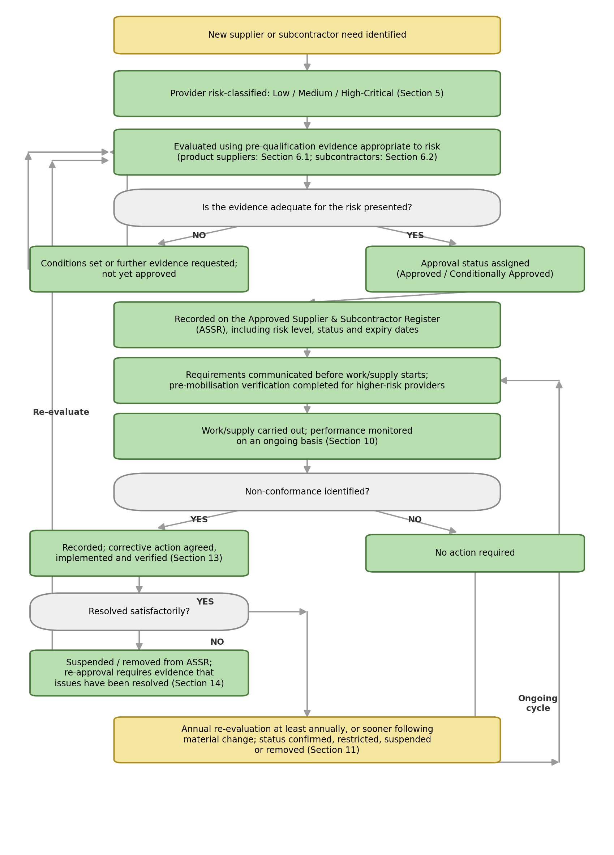

Signed
Name
Position | Director
Date

