Company Ltd
Documents, Data and Records Procedure

Scope:

This procedure shall apply to the documents, data and records held by and required for the safe and efficient performance of the undertakings of the company.

Objectives:

- To ensure that documents held or issued are approved for adequacy prior to use
- To ensure that documents are reviewed and updated and re-approved as required
- To ensure that all documentation held by the company is available in it’s most up to date version and that the revision status of documents is identified
- To ensure that documents remain legible and identifiable
- To ensure a consistent approach to document control throughout the company
- To aid in regulatory compliance throughout the company
- To prevent the unintended use of obsolete documents
- To ensure that all staff (including sub-contractors) have ready access to the information required prior to undertaking work on site
- To ensure that obsolete documents are retained for information
- To ensure that records are identifiable, stored correctly and protected
- To ensure that records are disposed of appropriately

Documents:

Documents may be generated internally or externally and may consist of:

- Correspondence
- Delivery notes and certification where required, for example, materials testing certificates and stock provenance certificates
- Training records and certificates
- Protected species licenses
- Contract Documentation and client orders
- Instructions to site staff
- Location and identification of underground and over ground services and structures and name, address, telephone numbers of persons responsible for them
- Health and safety information or requirements
- Location and identification of protected species and their habitats and of government bodies authorised to issue licences, including name, address, and telephone numbers of persons responsible
- Where appropriate, location and identification of trees covered by TPO’s and Conservation Areas and of the Local Authority administering protection
- Environmental management and landscape plans
- Contract Drawings

Document Review:

In the absence of any other reason, documents shall be reviewed in line with the following requirements:

Document Type | Review Frequency
Policies | 12 months
Procedures | 12 months
Forms | As required
Generic risk Assessments | 12 months
COSHH Assessments | 24 months
Web Links | 12 months
External Documents such as British Standards | Monthly
Specific risk assessments | Daily or in the event of any change in the circumstances on site

The review date and the current version number shall be shown in the document footer for internal documents.

Document Type:

The following hierarchy shall be followed in relation to the format of individual documents held. The preference shall be for a link to externally controlled electronic documents from a credible source in order that only the most up to date version can be used for reference.

- Externally controlled electronic documents from a credible source as a link from the Compliance Register
- Electronic documents held in the electronic Company Library
- Books and other hard copy information held in the Company Library

Records:

Records may be generated internally or externally.

- Contract specifications and any variations
- Invoices/receipts from sub-contractors
- Instructions to site staff
- Written complaints and details of corrective and preventive actions
- Experience and training records for all personnel
- Details of any accidents (known to the organisation) in or adjacent to the landscape, environment or ecology works and details of follow up activity
- Licences for works affecting protected species or their habitats, and protected trees.
- Records of pesticide use
- Vehicle, plant and equipment maintenance records
- Operational site diary/daily record
- QMS system records such as management review meeting minutes and internal audit reports

Record Retention Times:

- Health surveillance and exposure records required under COSHH, the Control of Noise at Work Regulations or the Control of Vibration at Work Regulations shall be retained for at least 40 years from the date of the last entry
- Accident, incident and RIDDOR records shall be retained for at least 3 years from the date of the event, and longer where a claim might reasonably still arise or where the individual's exposure history may be relevant to a future health surveillance record
- All other records shall be retained for at least 7 years
- Daily job sheets shall be retained for at least 1 year

These are minimum retention periods. Records containing personal data shall be reviewed for continued necessity and securely destroyed once neither legally required nor operationally needed, in line with UK GDPR and Data Protection Act 2018 data minimisation principles.

- The electronic storage of records shall be the preferred method of storage.
- Electronic records shall be backed up regularly and the backup copy stored off site.
- Recent paper records shall be stored in such a way to allow ready access to the information.
- Old paper records shall be stored in dated boxes in an archive room.

Versioning Convention:

Version | Reason
Version Draft (VD) | The version of the document that has not yet been approved for addition to the management system
Version 1 (V1) | The first version of the document that has been accepted for addition to the management system
Version 2 (V2) | The second version of the document that has been subject to review where changes were made.  The publication date would be updated to reflect the reviewed-on date

Font:
All documents produced by [COMPANY NAME] shall be created using [insert font type], font size [insert font size] in black.

Footer Format:

A footer shall be added to the document, or the existing footer shall be amended to show the new status.

The footer shall be formatted in line with the standard shown below:

- Company
- Document name
- Document Reference
- Version Number
- Date of version
- Review Date
- Page X of Y

The footer shall be created using [insert font], font size [insert size] in [insert colour].

Example:

[COMPANY NAME] – Document Name – ARB-PROC - 09
Version: [VERSION] Date Issued: [DATE] Review Date: [REVIEW DATE]
Not controlled when printed

Document Security:

Documents sent by email or given to clients in electronic format shall be in locked PDF format.

Legislative & Best Practice Framework:

This procedure has regard to the following legislation and guidance. This list reflects the law known to be current at the time this procedure was last reviewed and is not exhaustive:

- UK GDPR and Data Protection Act 2018 – lawful handling, retention and secure destruction of records containing personal data
- Health and Safety at Work etc. Act 1974 – general duty to keep records supporting the management of health and safety
- Control of Substances Hazardous to Health Regulations 2002 (COSHH), Regulation 11 – 40-year retention of health surveillance records where required
- Control of Noise at Work Regulations 2005 and Control of Vibration at Work Regulations 2005 – retention of related health surveillance records
- Reporting of Injuries, Diseases and Dangerous Occurrences Regulations 2013 (RIDDOR) – duty to keep records of reportable events
- Limitation Act 1980 – informs how long accident and incident records should reasonably be kept in case of a future civil claim
- Working Time Regulations 1998 – records of working time where applicable
- Companies Act 2006 – retention of statutory accounting records, where relevant to the Company's administrative records
- Construction (Design and Management) Regulations 2015 – retention of the health and safety file for the life of a structure, where CDM applies to the Company's work

Process Owner:

NAME - ROLE

Authorisation & Responsibility:

New and updated documents are reviewed and approved for use by the management team, as shown in the process below. Day-to-day coordination of the document control system (adding documents, updating footers and versions, and archiving obsolete documents) is carried out by the Process Owner. A Director retains overall responsibility for the effectiveness of this procedure.
See below for the flowchart.
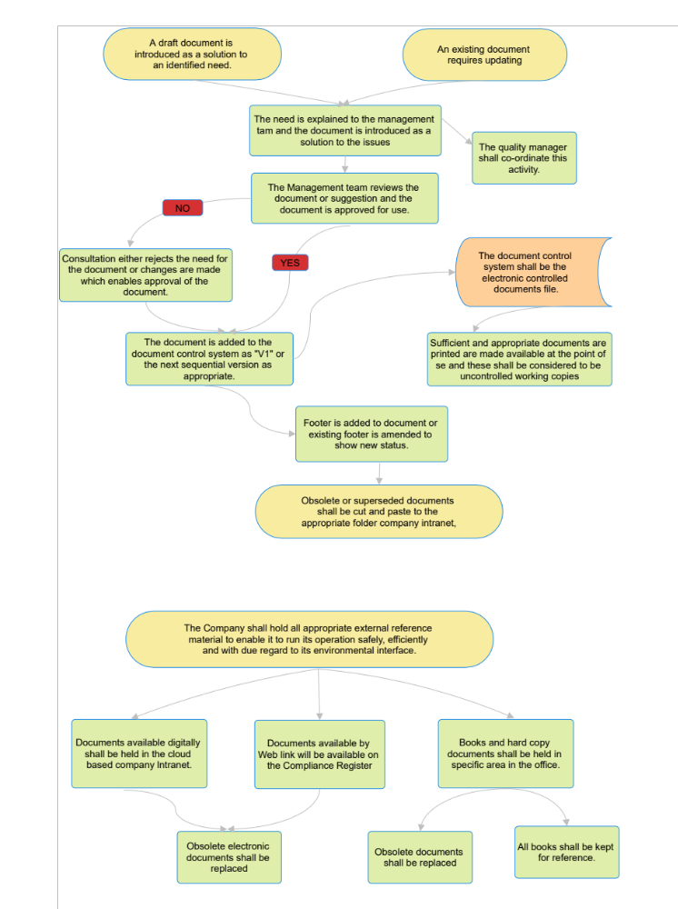
Process Summary:

The process is illustrated in the flowchart above. A draft document is introduced as a solution to an identified need, or an existing document requires updating; the need is explained to the management team, who review and approve the document for use. Approved documents are added to the document control system with the appropriate version number, and a footer is added or amended to show the new status. Obsolete or superseded documents are moved to the appropriate archive folder rather than deleted, so a record of prior versions is retained. Separately, external reference material the Company relies on to operate safely, efficiently and with due regard to its environmental interface is held digitally, by web link on the Compliance Register, or as hard copy in the office, and is replaced when it becomes obsolete.

Document Control:

This procedure is communicated to relevant staff, reviewed at least annually or sooner following legislative change, incidents or significant operational changes, and approved by a director.

Signed
Name
Position | Director
Date

