Company Ltd
Legal and Other Requirements Procedure

Scope:

This procedure describes the process of:

- Identifying all applicable legal and other requirements relating to OH&S hazards and environmental aspects and impacts.
- Gaining access to all legal and other requirements.
- Determining how the legal and other requirements apply to the undertakings of the organisation.

Objectives:

- To ensure that all sources of compliance are identified.
- To ensure that the company has access to all sources of compliance.
- To ensure that all legal requirements receive consideration and that control measures are put in place.
- Where a product is subject to a legal conformity marking requirement (for example PPE, machinery or other regulated equipment), it carries the appropriate current marking – CE marking is currently accepted indefinitely in Great Britain for most such products, alongside the UKCA mark, which remains available but voluntary (see the PPE Issue, Replacement and Inspection Procedure for current detail).

Legislative & Best Practice Framework:

This procedure has regard to the following legislation and standards. This list reflects the law and standards known to be current at the time this procedure was last reviewed and is not exhaustive:

- Health and Safety at Work etc. Act 1974 – general duty to identify and comply with applicable health and safety law
- ISO 45001:2018, Clause 6.1.3 (Determination of legal requirements and other requirements) – the current international standard for occupational health and safety management, which superseded OHSAS 18001 (certificates to OHSAS 18001 ceased to be valid from 11 March 2021)
- ISO 14001:2015, Clause 6.1.3 (Compliance obligations) – the equivalent requirement for environmental management
- UK product conformity marking requirements (UKCA/CE), where applicable to specific products used or supplied by the Company

Process Owner:

NAME - ROLE

Process:

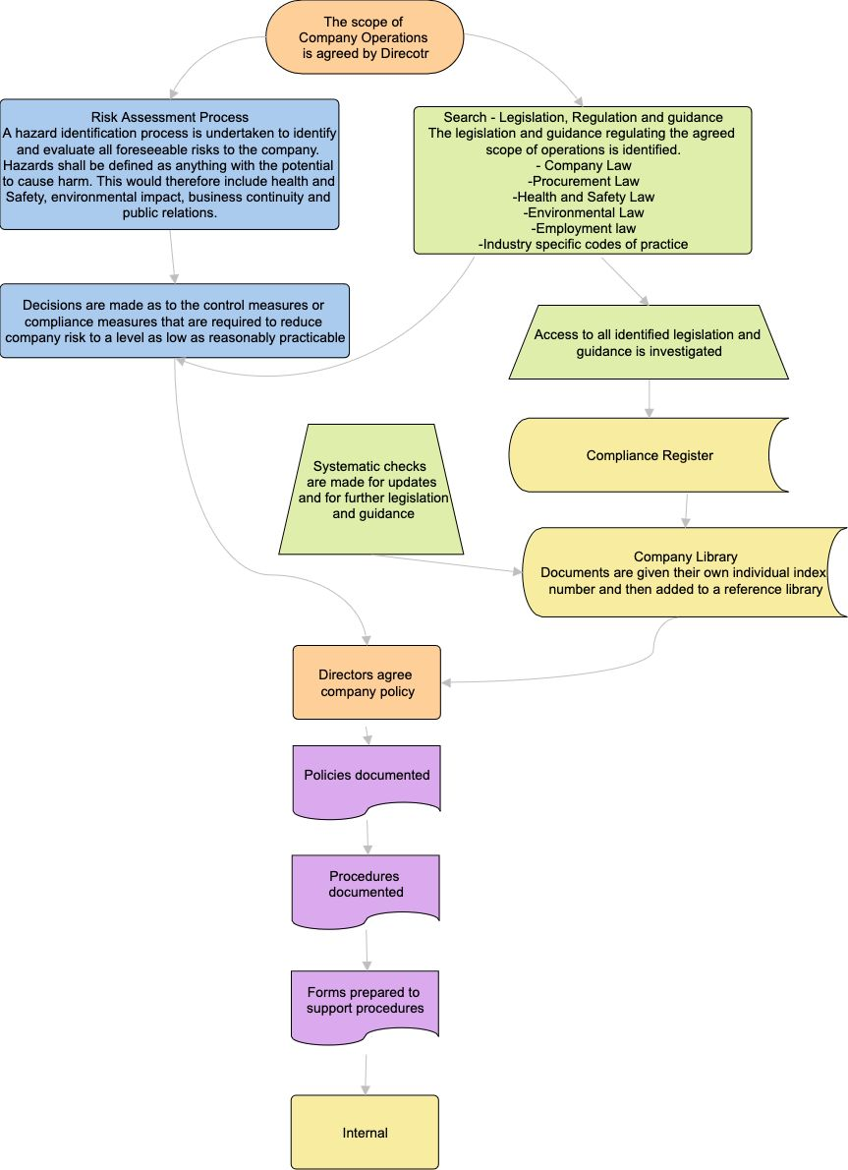

Process Summary:

The process is illustrated in the flowchart above and summarised as follows: the scope of Company operations is agreed by a Director; a hazard identification process (the Risk Assessment Process) is undertaken to identify and evaluate foreseeable risks – defined broadly as anything with the potential to cause harm, including health and safety, environmental impact, business continuity and public relations – in parallel with a search of the legislation, regulation and guidance relevant to the agreed scope of operations (company law, procurement law, health and safety law, environmental law, employment law and industry-specific codes of practice); decisions are made on the control or compliance measures needed to reduce risk to a level as low as reasonably practicable, while access to all identified legislation and guidance is investigated and recorded on the Compliance Register (see Appendix 2 of the Aspects and Impacts Register); systematic checks are made for updates and further relevant legislation or guidance; documents are given their own index number and added to the Company Library; Directors agree Company policy in response; and policies, procedures and forms are documented accordingly, feeding into the internal audit programme.

Records:

The Compliance Register, the Company Library index, and evidence of Director approval of Company policy are retained in line with the Documents, Data and Records Procedure.

Review:

Systematic checks are made for updates to identified legislation and guidance, and for newly relevant legislation or guidance, as shown in the process above. This procedure itself is reviewed at least annually, or sooner following a significant legislative change, an audit finding, or a change in the Company's activities, to confirm that arrangements remain effective.

Document Control:

This procedure is communicated to relevant staff, reviewed at least annually or sooner following legislative change, incidents or significant operational changes, and approved by a director.

Signed
Name
Position | Director
Date

