Company Ltd

Control of Measuring and Monitoring Equipment Procedure

Scope:

All equipment requiring calibration shall be logged and checked periodically.

Objectives:

- Measuring and monitoring equipment shall be maintained to be consistently accurate
- All equipment found to be out of calibration shall be added to the register and calibrated prior to further use

Typical Measuring and Monitoring Equipment:

Depending on the Company's activities, this may include tachographs, noise meters, anemometers/wind gauges used to assess safe working conditions for aerial work, diameter tapes and callipers, moisture meters, and torque wrenches. This list is not exhaustive.

Legislative & Best Practice Framework:

This procedure has regard to the following legislation and standards. This list reflects the law and standards known to be current at the time this procedure was last reviewed and is not exhaustive:

- ISO 9001:2015, Clause 7.1.5 (Monitoring and Measuring Resources) – the current international standard requirement for calibration or verification of measuring equipment used to demonstrate conformity
- Provision and Use of Work Equipment Regulations 1998 (PUWER) – work equipment must be maintained in an efficient state and inspected where appropriate
- Retained Regulation (EC) No 561/2006 (drivers' hours) and Retained Regulation (EU) No 165/2014 (tachographs), as amended – tachographs must be periodically calibrated and tested at an approved calibration centre. Tachograph rules currently apply to goods vehicles over 3.5 tonnes; from 1 July 2026 this extends to vehicles over 2.5 tonnes undertaking cross-border journeys. Purely domestic UK operation below 3.5 tonnes does not currently require a tachograph
- Control of Noise at Work Regulations 2005 – where noise meters are used to inform noise risk assessments
- Manufacturer's specified calibration interval and method for each item of equipment

Process Owner:

NAME - ROLE

Process:

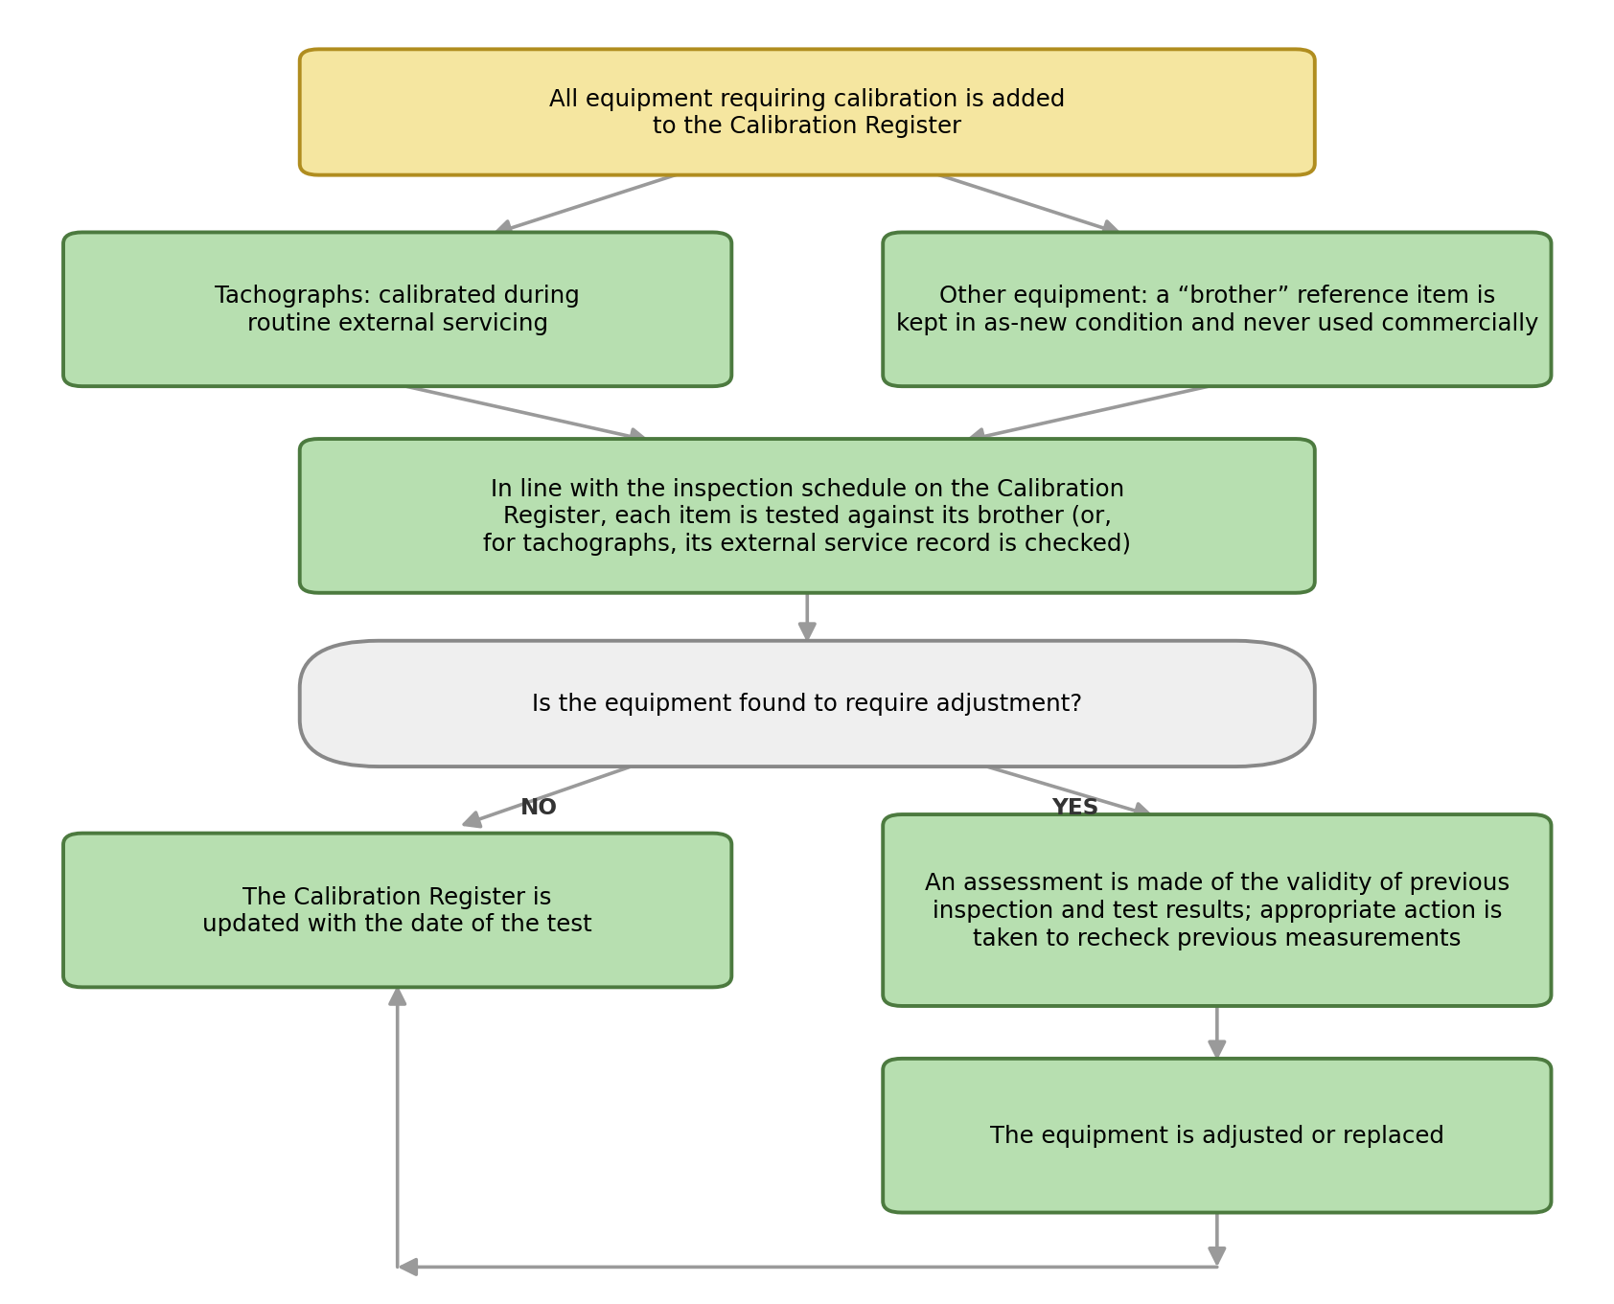
Process Summary:

The process is illustrated in the flowchart above and summarised as follows: all equipment requiring calibration is added to the Calibration Register. Tachographs are calibrated during routine external servicing at an approved calibration centre. Every other item of equipment requiring calibration has a “brother” item, kept in as-new condition and never used commercially, against which it is tested. In line with the inspection schedule on the Calibration Register, each item is tested against its brother (or, for tachographs, its external service record is checked). Where the equipment is found to require adjustment, an assessment is made of the validity of previous inspection and test results, and appropriate action is taken to recheck previous measurements before the equipment is adjusted or replaced. In all cases, the Calibration Register is updated with the date of the test.

Authorisation & Responsibility:

The Process Owner maintains the Calibration Register and inspection schedule. Where equipment is found to be out of calibration, the Process Owner determines, or escalates to a Director where the potential effect is significant, what previous measurements may need to be rechecked before the equipment is returned to use.

Records:

The Calibration Register, including test dates, results and any equipment adjusted or replaced, is retained in line with the Documents, Data and Records Procedure.

Review:

The inspection schedule on the Calibration Register is reviewed to reflect manufacturer guidance and actual equipment performance. This procedure itself is reviewed at least annually, or sooner following a significant calibration failure, an audit finding, or a change in legislation, to confirm that arrangements remain effective.

Document Control:

This procedure is communicated to relevant staff, reviewed at least annually or sooner following legislative change, incidents or significant operational changes, and approved by a Director.

Signed
Name
Position | Director
Date

