Company Ltd
Storage of Product Procedure

Scope:

This procedure shall apply to all products delivered into the company and subsequently stored and all product produced and stored by the company

Objectives:

- To reduce risk of injury through unnecessary manual handling
- To control risks of substances hazardous to health
- To control risks of substances hazardous to the environment
- To reduce risk of degradation of product or material
- To ensure effective storage and retrieval of materials and equipment
- To ensure appropriate storage where there is a demonstration of provenance requirement

Legislative & Best Practice Framework:

This procedure has regard to the following legislation and guidance. This list reflects the law known to be current at the time this procedure was last reviewed and is not exhaustive:

- Manual Handling Operations Regulations 1992, as amended – reducing risk from unnecessary manual handling during storage and retrieval
- Control of Substances Hazardous to Health Regulations 2002 (COSHH), as amended – see the COSHH Procedure
- Control of Pollution (Oil Storage) Regulations 2001 – secondary containment (bunding) for fuel and oil storage above specified thresholds
- Dangerous Substances and Explosive Atmospheres Regulations 2002 (DSEAR) – storage of flammable substances and control of fire hazards
- Regulatory Reform (Fire Safety) Order 2005 – fire risk assessment of storage areas
- Classification, Labelling and Packaging (CLP) Regulation, as it applies in Great Britain – labelling of stored hazardous products
- Hazardous Waste (England and Wales) Regulations 2005 (or equivalent) – disposal of deteriorated or unsuitable product
- Forest Reproductive Material (Great Britain) Regulations 2002, as amended – where storage must demonstrate provenance of seed or planting stock (see the Identification and Traceability Procedure)

Process Owner:

NAME - ROLE

Process:

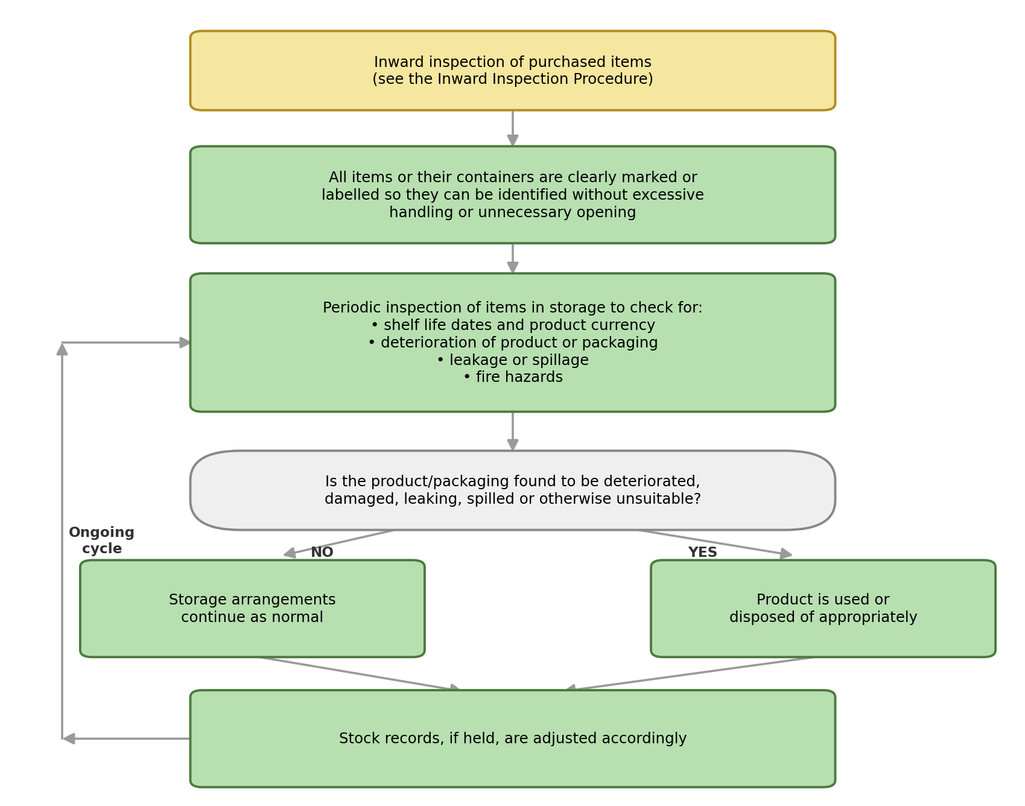
Process Summary:

The process is illustrated in the flowchart above and summarised as follows: following inward inspection of purchased items (see the Inward Inspection Procedure), all items or their containers are clearly marked or labelled so they can be identified without excessive handling or unnecessary opening. Items in storage are periodically inspected for shelf life dates and product currency, deterioration of product or packaging, leakage or spillage, and fire hazards. Where an item is found to be deteriorated, damaged, leaking, spilled or otherwise unsuitable, it is used (where still fit for purpose) or disposed of appropriately; otherwise, storage arrangements continue as normal. Stock records, if held, are adjusted accordingly, and the cycle of periodic inspection continues.

Authorisation & Responsibility:

The Process Owner is responsible for the periodic inspection schedule and for confirming that deteriorated, damaged or otherwise unsuitable product is used, disposed of, or escalated appropriately. Where a substance hazardous to health or the environment is involved, disposal is carried out in line with the COSHH Procedure and the Environmental & Sustainability Policy.

Records:

Stock records, inspection findings and evidence of appropriate disposal are retained in line with the Documents, Data and Records Procedure.

Review:

Storage arrangements and the periodic inspection schedule are reviewed to reflect the products and materials actually held. This procedure itself is reviewed at least annually, or sooner following an incident, a change in the products or materials stored, or a change in legislation, to confirm that arrangements remain effective.

Document Control:

This procedure is communicated to relevant staff, reviewed at least annually or sooner following legislative change, incidents or significant operational changes, and approved by a Director.

Signed
Name
Position | Director
Date

