COMPANY Ltd
Construction Products and Systems Installation Procedure
Scope:
This procedure applies whenever the installation of a construction product, proprietary system, fitting, or similar controlled product forms part of COMPANY Ltd's contracted works. COMPANY Ltd's normal activities are arboricultural and tree surgery works; installation of construction products or systems is not a routine part of the business, but this procedure sets out the arrangements that apply on the occasions when it does occur — for example (this list is not exhaustive):
- Installation of proprietary tree protection or root protection systems (e.g. cellular confinement, root barriers, no-dig ground protection panels) specified by a client, engineer or arboricultural consultant
- Installation of fixings, brackets, guying, staking or anchoring systems for retained or replacement trees
- Installation of manufactured tree pit, tree grille, tree guard or irrigation systems
- Installation of drainage, edging, surfacing or other landscape construction products associated with tree works
- Any other proprietary product or system supplied with manufacturer's installation instructions or a technical specification
This procedure applies equally where such work is carried out directly by COMPANY Ltd or where it is sub-let to a specialist contractor acting on COMPANY Ltd's behalf. This procedure does not apply to routine arboricultural consumables, tools or equipment used by COMPANY Ltd's own operatives in the course of normal tree work, which are addressed by the Inward Inspection of Purchased Items Procedure and relevant risk assessments/method statements.
Objectives:
- To ensure that any construction product or system forming part of contracted works is correctly identified before work begins
- To ensure that installation is carried out in accordance with the client specification, manufacturer's instructions and any applicable technical or regulatory requirements
- To ensure that installation is undertaken only by personnel with the appropriate competence, whether employed directly or engaged as a specialist sub-contractor
- To ensure that every installation is formally checked and approved by a competent person before it is accepted as complete
- To ensure that any substitution or deviation from the specification is properly authorised and recorded
- To ensure that defects or non-conformities are identified, rectified and re-inspected before approval is given
- To maintain auditable records demonstrating that these arrangements have been followed
- To provide clients, principal contractors and accreditation bodies with credible evidence that construction products and systems forming part of COMPANY Ltd's works are properly controlled, even where this is not a routine part of the business
Definitions:
Construction product or system: any manufactured product, proprietary system, fitting or material supplied with manufacturer's installation instructions, technical specification or performance requirements, the incorrect installation of which could affect its performance, safety or compliance with the client's specification.
Competent person: a person whose competence to install and/or inspect a specific construction product or system is demonstrated by a combination of the following, appropriate to the product or system involved (see the specific competence requirements set out below):
• A recognised construction site competence card, such as CSCS (Construction Skills Certification Scheme), appropriate to the person's role, which requires a current CITB Health, Safety and Environment Test pass
• Manufacturer product-specific installer training or certification for the exact system being installed, where the manufacturer offers this (many root protection, guying/anchoring and tree pit system manufacturers provide installer training and issue a certificate or approved installer status – evidence of this is the strongest and most specific evidence of competence for that product)
• A relevant vocational qualification such as an NVQ/SVQ, City & Guilds or T Level in Amenity Horticulture, Landscape Construction, or Construction (Groundworks), at a level appropriate to the complexity of the work
• Documented practical experience of installing the same or a closely comparable product or system – recorded as a minimum number of completed installations, or a minimum period of relevant experience, with references or job records available on request

Competence is assessed and recorded in line with the Competence Management arrangements for the relevant role and may be held by a COMPANY Ltd employee or by an appointed specialist sub-contractor. The person approving completed installation under this procedure must not be the same person who carried out the installation, unless no other competent person is reasonably available, in which case this shall be recorded and justified.

Specific Competence Requirements by Product/System Type:

The table below sets out the competence evidence expected for each type of construction product or system covered by this procedure's Scope. This list is not exhaustive; where a product or system is not listed, competence shall be assessed against the general criteria above.

Product / system type | Specific competence evidence expected
Tree/root protection systems (e.g. cellular confinement, root barriers, no-dig ground protection) | Manufacturer installer training/certification for the specific system; CSCS card; NVQ Level 2/3 Amenity Horticulture or Landscape Construction, or documented equivalent experience of at least 2 similar installations
Guying, staking or anchoring systems | Manufacturer installer training for the specific anchor/guying system (e.g. Platipus, Duckbill or equivalent); Arboricultural Association or NPTC tree planting/establishment training; documented practical experience
Manufactured tree pit, tree grille, tree guard or irrigation systems | Manufacturer installer training/certification where offered; CSCS card; documented practical experience of installing the specific or a closely comparable system
Drainage, edging, surfacing or other landscape construction products | CSCS card (appropriate category); NVQ/City & Guilds in Construction (Groundworks) or Landscape Construction; documented practical experience
Any other proprietary product or system | Assessed against the general competence criteria above, with particular weight given to manufacturer-specific training where the manufacturer provides it

Process Owner:
NAME – ROLE
Related Procedures:
This procedure operates alongside, and should be read in conjunction with, the following management system procedures:
- Inward Inspection of Purchased Items Procedure – checking of products/materials on receipt against specification
- Identification and Traceability Procedure – identification and traceability of products where required
- Competence Management arrangements – assessment and recording of individual competence
- Supplier Evaluation and Control arrangements – evaluation and approval of specialist sub-contractors
- Documents, Data and Records Procedure – control and retention of records generated under this procedure
- Risk Assessment and Method Statement arrangements – safe system of work for the installation activity itself
Procedure / Process:
1. Identify at the earliest opportunity (tender, order or pre-start stage) whether any construction product or proprietary system forms part of the contracted works, using the client's specification, drawings, tree survey/arboricultural report or method statement.
2. Review the client specification, drawings, manufacturer's installation instructions and any other technical information relevant to the product or system and confirm these are available on site before work begins.
3. On delivery, check the product/materials received against the specification and order in line with the Inward Inspection of Purchased Items Procedure. Retain certification or technical data sheets supplied with the product.
4. Where required by the specification or by the nature of the product, identify and maintain traceability of the product in line with the Identification and Traceability Procedure (for example, by batch/reference number, delivery note or job number).
5. Assess the competence required to install the product or system correctly, with reference to the manufacturer's instructions and the specification.
6. Where the required competence is available in-house, appoint a suitably competent employee to carry out the installation, confirmed against current Competence Management records.
7. Where the required competence is not available in-house, appoint an appropriately competent specialist sub-contractor, selected and evaluated in line with Supplier Evaluation and Control arrangements. Evidence of the sub-contractor's competence (e.g. manufacturer accreditation, trade certification, references) shall be obtained and retained before appointment.
8. Carry out (or oversee) installation strictly in accordance with the manufacturer's instructions, the client specification and any applicable regulatory or technical requirements.
9. Where any substitution of product or deviation from the specification is proposed, obtain written authorisation from the client or their representative (and from the manufacturer where the substitution affects a warranty or performance requirement) before proceeding. Record the reason for and authorisation of the substitution.
10. On completion, inspect and check the installation against the specification and manufacturer's requirements.
11. Arrange for the completed installation to be formally checked and approved by a competent person before it is accepted as complete. The competent person, and the date and outcome of the check, shall be recorded (for example on the job sheet, an inspection/handover form, or within the project file).
12. Where the inspection identifies a defect, non-conformity or incorrect installation, record the finding, carry out rectification, and re-inspect the affected element before approval is given. Installation shall not be accepted as complete until re-inspection confirms the defect has been resolved.
13. Where required by the client, principal contractor or manufacturer, provide handover information, guidance or certification for the installed product or system (for example, manufacturer's guarantee, maintenance requirements or as-built information).
14. Retain all records generated under this procedure (specification, delivery/inspection records, competence evidence, substitution authorisations, approval records, handover certification) in line with the Documents, Data and Records Procedure.
15. Review the operation of this procedure at least annually, or following any relevant non-conformity, client complaint or change in the type of construction products/systems encountered, and update the procedure as necessary.
Process Overview:
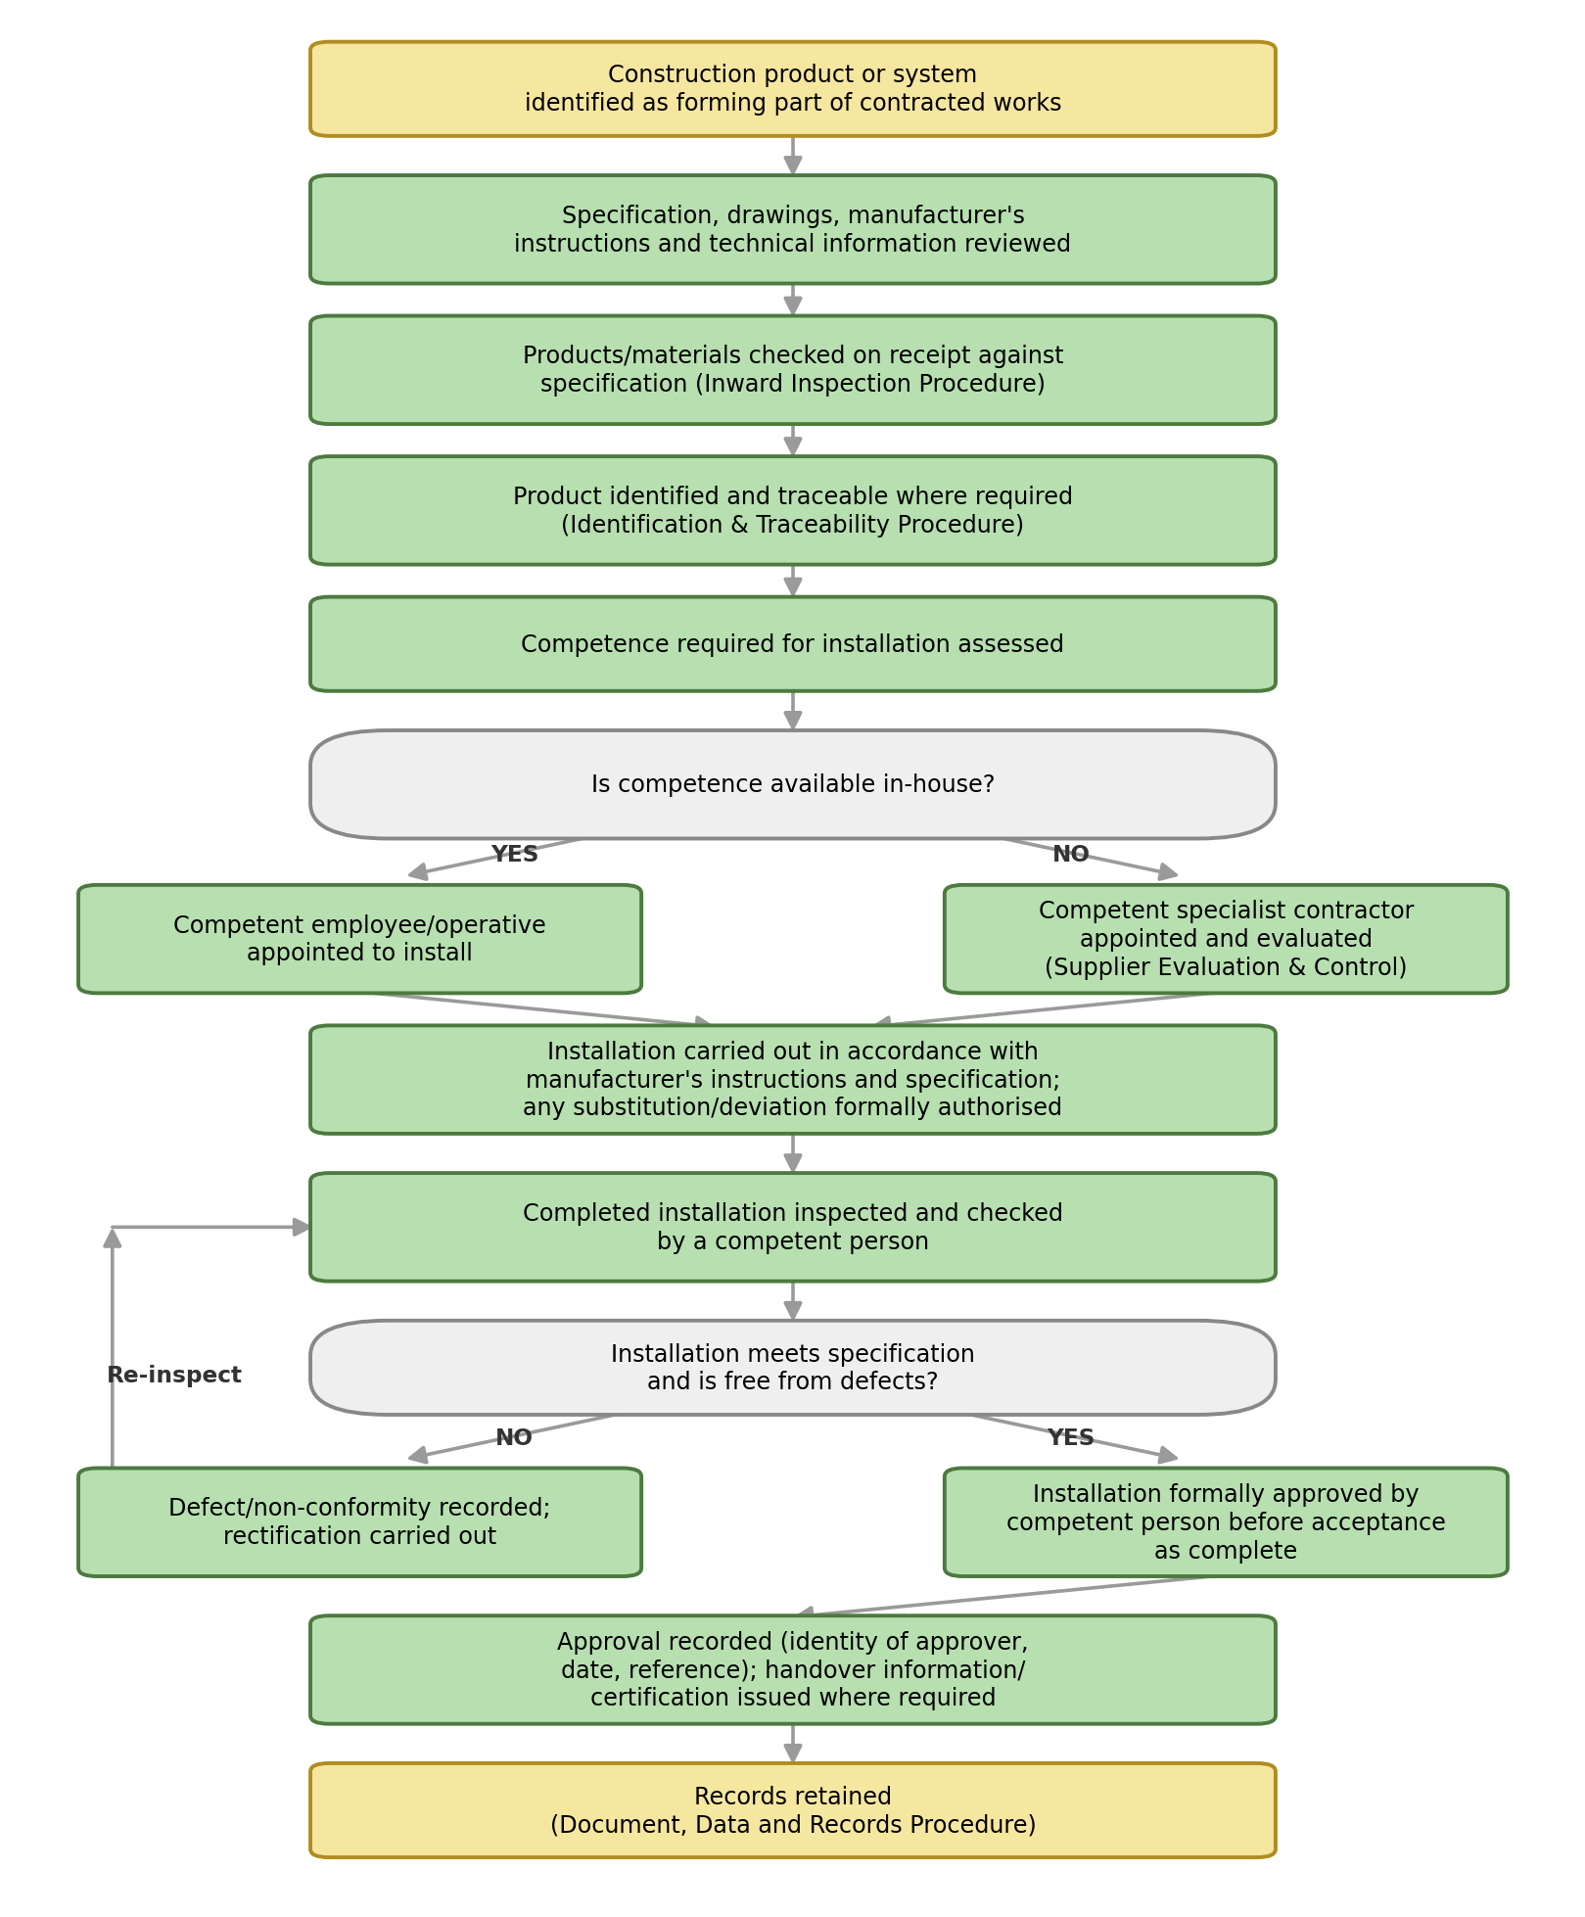
Records:
The following records shall be retained as evidence that this procedure has been followed:
- Client specification, drawings and manufacturer's instructions relevant to the installed product/system
- Delivery/inward inspection records for the product or system
- Evidence of competence of the installer against the specific competence requirements above – for example a copy of the CSCS card, manufacturer installer training certificate, vocational qualification certificate, or a record of documented practical experience – whether the installer is a COMPANY Ltd employee or an appointed specialist sub-contractor
- Written authorisation of any product substitution or specification deviation
- Completed installation inspection and approval record, including the identity of the competent person and date of approval
- Records of any defect, non-conformity, rectification and re-inspection
- Handover information or certification issued to the client
Records shall be retained in line with the retention periods set out in the Documents, Data and Records Procedure.

