COMPANY Ltd
Product and Equipment Conformity and Intended Use Procedure

Scope:

This procedure sets out COMPANY Ltd's arrangements for ensuring that all products, equipment and systems used in its arboricultural, vegetation management and related work conform to their designated standard or relevant independent certification and are used only for their intended purpose. It applies to (this list is not exhaustive):

- Personal protective equipment (PPE), including chainsaw protective clothing, helmets, gloves and hi-vis clothing
- Chainsaws, chippers, stump grinders and other powered hand tools and machinery
- Climbing, rigging and fall-protection equipment
- Mobile Elevating Work Platforms (MEWP) and other lifting equipment
- Vehicles, trailers and vehicle-mounted equipment
- Herbicides, pesticides and other plant protection products
- Construction products and systems (see also the Construction Products and Systems Installation Procedure, which covers installer competence for this category)

This procedure applies whether the product or equipment is owned by COMPANY Ltd, hired, or provided by a specialist sub-contractor engaged on COMPANY Ltd's behalf.

Objectives:

- To ensure the applicable designated standard or independent certification for each category of product or equipment is identified before purchase or use
- To ensure conformity evidence is checked and retained at the point of purchase or delivery
- To ensure products and equipment continue to conform through their working life, through periodic inspection, thorough examination or calibration where required
- To ensure products and equipment are used only for their intended, certified purpose, and never beyond their rated capacity or outside an approved application
- To ensure non-conforming, damaged, expired or misused products and equipment are withdrawn from use immediately
- To maintain auditable records demonstrating that these arrangements have been followed

Definitions:

Designated standard: a British Standard (BS), European Standard (EN), harmonised standard, HSE-approved code of practice, or manufacturer specification that a product or piece of equipment is designed, manufactured and tested to meet.

Independent certification: third-party verification that a product meets its designated standard – for example CE or UKCA marking, a LOLER thorough examination certificate, or inclusion on the HSE's GB Pesticides Approvals Register.

Intended purpose: the use(s) for which a product or piece of equipment is designed, tested and certified by its manufacturer, as set out in its instructions, technical specification, rated capacity (for example Safe Working Load) or product authorisation.

Legislative & Best Practice Framework:

This procedure has regard to the following legislation and standards. This list reflects the law and standards known to be current at the time this procedure was last reviewed and is not exhaustive:

- Provision and Use of Work Equipment Regulations 1998 (PUWER) – work equipment must be suitable for the purpose for which it is used, and used only for operations, and under conditions, for which it is suitable
- Lifting Operations and Lifting Equipment Regulations 1998 (LOLER) – lifting equipment must not exceed its Safe Working Load and must be thoroughly examined at the required interval
- Personal Protective Equipment at Work Regulations 1992, as amended by the Personal Protective Equipment at Work (Amendment) Regulations 2022, and Regulation (EU) 2016/425 as incorporated into UK law and the Personal Protective Equipment (Enforcement) Regulations 2018 – conformity marking for PPE (see the PPE Issue, Replacement and Inspection Procedure for further detail)
- Retained Regulation (EC) No 1107/2009 on plant protection products – herbicides and pesticides must be approved by HSE's Chemicals Regulation Division and used strictly in accordance with the conditions of that approval
- BS 3998 (Tree Work – Recommendations) and current Arboricultural Association/AFAG technical guidance on equipment appropriate to arboricultural operations
- Health and Safety at Work etc. Act 1974

Process Owner:

NAME – ROLE

Related Procedures:

This procedure operates alongside, and should be read in conjunction with, the following management system procedures:

- Inward Inspection of Purchased Items Procedure – checking of products/materials on receipt against specification
- Construction Products and Systems Installation Procedure – installer competence for construction products/systems
- PPE Issue, Replacement and Inspection Procedure – PPE-specific conformity marking, inspection and replacement
- Work Equipment Inspection and Use Procedure – routine inspection and safe use of work equipment
- Measuring and Monitoring (Calibration) Procedure – calibration of measuring equipment
- Competence Management Procedure – training and briefing on correct use of equipment
- COSHH Procedure – safe use of hazardous substances, including herbicides and pesticides
- Documents, Data and Records Procedure – control and retention of records generated under this procedure

Process:

See below for the flowchart.

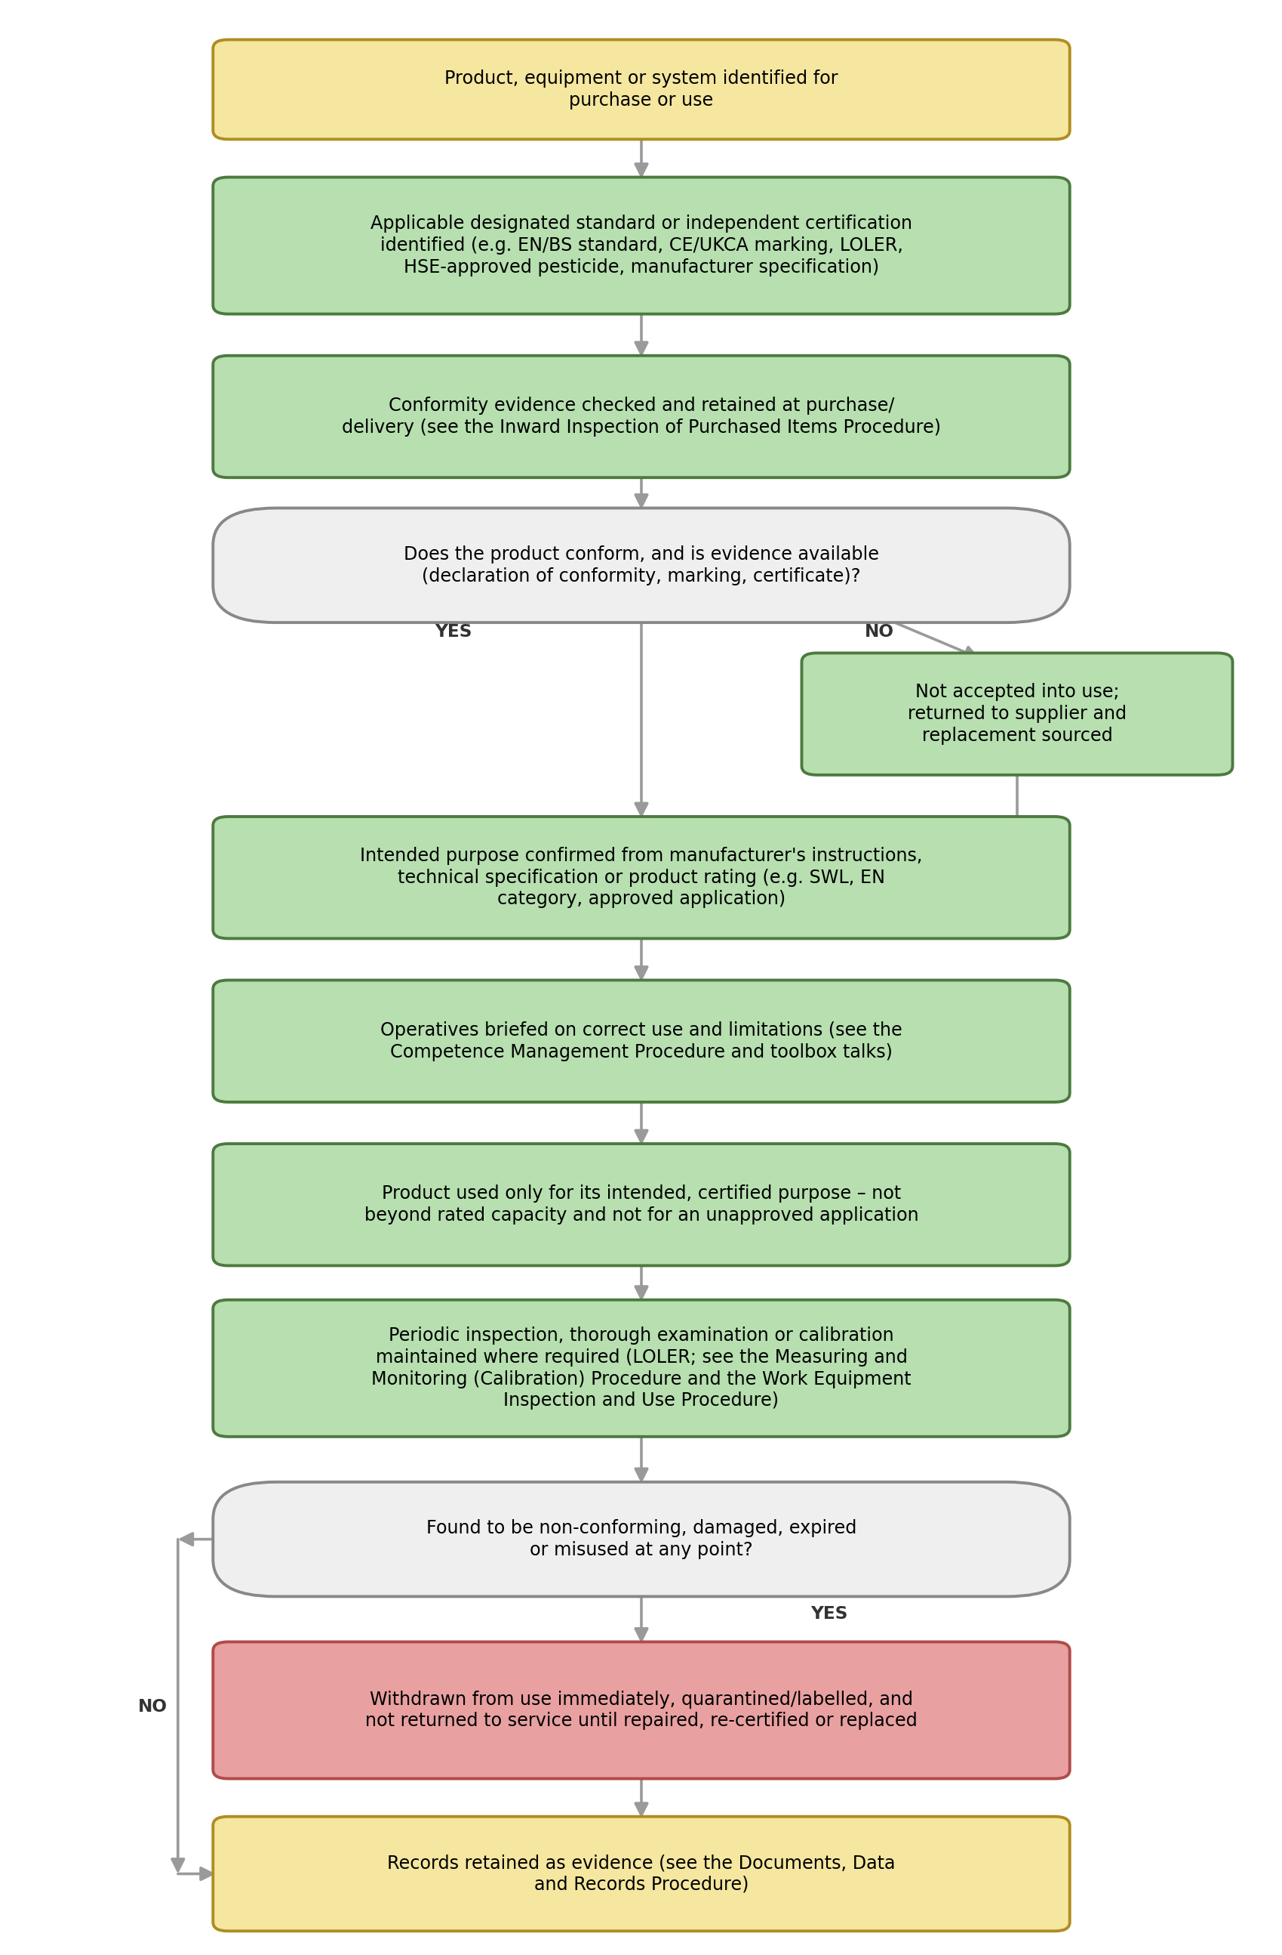

Process Summary:

The process is illustrated in the flowchart above and summarised as follows: when a product, item of equipment or system is identified for purchase or use, the applicable designated standard or independent certification is identified, and conformity evidence is checked and retained at purchase or delivery, in line with the Inward Inspection of Purchased Items Procedure. Where the product does not conform, or evidence is not available, it is not accepted into use and is returned to the supplier. Where it does conform, its intended purpose is confirmed from the manufacturer's instructions, technical specification or rated capacity, and operatives are briefed on correct use and limitations before the product is used – only for its intended, certified purpose, never beyond its rated capacity and never for an unapproved application. Where periodic inspection, thorough examination or calibration is required to maintain conformity, this is carried out at the required interval. If, at any point, a product or item of equipment is found to be non-conforming, damaged, expired or has been misused, it is withdrawn from use immediately, quarantined or labelled accordingly, and not returned to service until it has been repaired, re-certified or replaced. Records are retained throughout as evidence that these arrangements have been followed.

Authorisation & Responsibility:

The Process Owner is responsible for identifying the designated standard or certification requirement for each category of product or equipment used by the Company, and for maintaining the arrangements set out in this procedure. The Team Leader or Manager responsible for a job is responsible for confirming, before work starts, that the equipment to be used conforms, is within any required inspection or examination interval, and is being used for its intended purpose. Any employee, subcontractor or supplier may, and is expected to, identify and report a product or item of equipment they believe to be non-conforming, damaged or being misused.

Records:

The following records are retained as evidence that this procedure has been followed:

- Declarations of conformity, CE/UKCA marking evidence, and BS/EN certification for relevant products and equipment
- LOLER thorough examination certificates and other periodic inspection or calibration records
- Evidence that herbicides/pesticides used are included on the HSE's GB Pesticides Approvals Register and are used in accordance with their approved conditions of use
- Training or briefing records confirming operatives understand the correct use and limitations of equipment
- Records of any product or item of equipment withdrawn from use, quarantined, repaired, re-certified or replaced

Records are retained in line with the retention periods set out in the Documents, Data and Records Procedure.

Review:

This procedure is reviewed at least annually, or sooner following a non-conformity, an incident, a client complaint, an audit finding, or a change in the standards, certification requirements or legislation applicable to the products and equipment the Company uses.

Document Control:

This procedure is communicated to relevant staff and subcontractors, made available to clients, buyers, auditors and accreditation bodies on request, reviewed at least annually or sooner following legislative change, incidents or significant operational changes, and approved by a director.

Signed
Name
Position | Director
Date

