[COMPANY NAME Ltd]
Environmental Operations System
Document reference | ARB-ENV-01
Version | [x.x]
Date issued | [dd/mm/yyyy]
Next review date | [dd/mm/yyyy]
Document owner | [NAME – ROLE]
Approved by | [NAME – Director]

1. Purpose
At [COMPANY NAME] we believe looking after the environment should be practical, proportionate and part of everyday tree work – not something that only lives in a policy folder.
This document explains how our environmental system works. It sets out:
- the documents that make up the system and how they link together
- how we make sure everyone working for us has the knowledge, training and competence to protect the environment
- who is responsible for what
- the records we keep to show we are doing what we say.
It puts our Environmental Policy into practice and supports our commitments to prevent pollution, protect wildlife and trees, comply with the law, meet our clients' requirements and keep improving.

2. Scope
This document applies to everyone who works for or on behalf of [COMPANY NAME], including Directors, Managers, Team Leaders, employees, apprentices, agency workers and subcontractors. It covers all our work activities – on client sites, at our yard and depot, in our vehicles and in the office.
Training is always proportionate to each person's role and the environmental risks of the work they do. A climber working near watercourses needs more than an office administrator, for example.

3. Key terms
Term | What it means
Environmental aspect | Part of our work that can affect the environment – for example refuelling a chainsaw, chipping arisings or felling a tree with bat roost features.
Competence | Having the right training, knowledge, experience and behaviour to do a task safely and correctly.
Site environmental briefing | A short talk by the Team Leader before work starts, covering the environmental risks and controls for that site.
Toolbox talk | A short, focused training session (usually 10–20 minutes) on one topic.
Biosecurity | Steps we take to stop tree pests, diseases and invasive plants spreading on our kit, vehicles, clothing and arisings.
Environmental incident | Any event that harms, or could have harmed, the environment – such as a fuel spill, a disturbed nest, or waste going to the wrong place. A near miss is an incident that could have caused harm but didn't.

4. Legal and other requirements
Our environmental system is designed to help us meet the law and the expectations of our clients and accreditation bodies. The main requirements for our type of work are listed below. Full details, links and review dates are kept in our Compliance Register.
Area | What it means for us | Where it's covered
Waste duty of care and waste carrier registration | We must store, transport and pass on waste (including arisings and woodchip) properly, use registered carriers and keep waste transfer notes for at least 2 years. Rules differ in Scotland and Northern Ireland. | Waste Management Procedure; Compliance Register
Waste exemptions | Some activities, such as chipping or burning at our yard, may need a registered exemption or authorisation. Scottish exemptions are being replaced by SEPA authorisations from 31 October 2026. | Waste Management Procedure; Compliance Register
Fuel and oil storage | Business oil containers over 200 litres (any size in Scotland) need secondary containment, usually 110% of the container. Bowsers need lockable taps and a drip tray or bund. | Spill Response Procedure; yard inspections
Wildlife | Nests are protected whenever they are being built or used. Bat roosts are protected even when bats are not there. Badger setts and other protected species must not be disturbed. | Wildlife and Ecology Procedure; site briefings
Tree pests, diseases and invasive species | We must comply with plant health notices (e.g. oak processionary moth) and must not spread invasive plants such as Japanese knotweed. | Biosecurity Procedure
Tree permissions | Tree Preservation Orders, conservation areas and felling licences must be checked before work starts. | Job sheets; Site-Specific Risk Assessments
Pesticides | Anyone applying herbicide professionally (e.g. stump treatment) must hold a recognised certificate. | Training Dashboard; COSHH assessments
Accreditation and client requirements | Schemes such as ARB Approved Contractor, Constructionline and CHAS expect an environmental policy, training, monitoring and review, and controls over subcontractors. | This document set

5. How the environmental system fits together
Our environmental system is made up of the documents below. Each one has a clear job, and together they show how we plan, do, check and improve our environmental performance.
Ref | Document | What it's for
[ref] | Environmental Policy | Our commitments, signed by the Director(s).
ARB-ENV-01 | Environmental Operations System (this document) | How the system works, training and competence, responsibilities and records.
ARB-ENV-02 | Environmental Induction Checklist | Records the environmental induction for every new starter and subcontractor.
ARB-ENV-03 | Environmental Training Dashboard | Shows who has had which training, and when refreshers are due.
ARB-ENV-04 | Environmental Annual Training Plan | Plans courses and the monthly toolbox talk programme for the year.
ARB-ENV-05 | Environmental Monitoring, Review and Continual Improvement Procedure | How we check our controls are working and how we improve.
[ref] | Operational procedures | Waste Management, Spill Response, Biosecurity, Wildlife and Ecology, and Environmental Aspects and Impacts procedures.
[ref] | Forms and records | Environmental Incident Report, Environmental Inspection Checklist, Toolbox Talk Register, Corrective Action Log.
[ref] | Job documents | Site-Specific Risk Assessments, Method Statements and job sheets – where environmental controls are applied on each job.
Replace [ref] with your own document references.

6. Environmental training and competence
Everyone builds and keeps their environmental competence through five stages. The flowchart below shows how they link together.
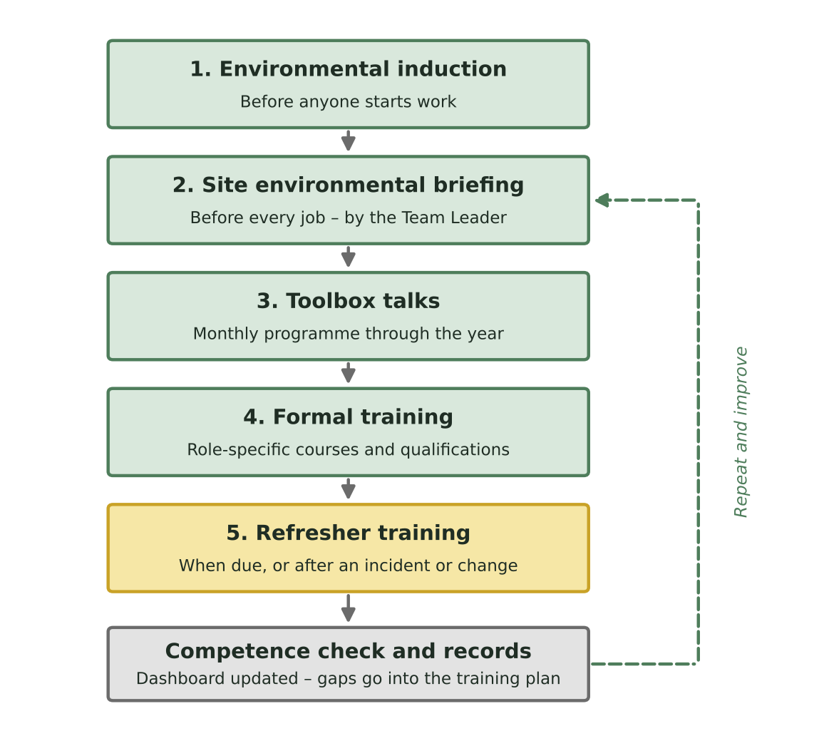

Stage 1 – Environmental induction
Every new employee, apprentice, agency worker and subcontractor has an environmental induction before they start work. It is recorded on the Environmental Induction Checklist (ARB-ENV-02) and covers our Environmental Policy, personal responsibilities, waste, fuel and spills, wildlife, biosecurity, tree permissions, nuisance to neighbours and how to report incidents.

Stage 2 – Site environmental briefing
Before work starts on every job, the Team Leader briefs the team on the environmental risks for that site and how they will be controlled. This includes protected species and nesting birds, bat roost features, invasive species, nearby drains and watercourses, refuelling and spill kit location, waste arrangements, tree permissions and any client requirements. The briefing is recorded on the job sheet or Site-Specific Risk Assessment and signed by the team.

Stage 3 – Toolbox talks
Environmental toolbox talks are given throughout the year following the programme in the Annual Training Plan (ARB-ENV-04). Topics are timed to the season – for example nesting birds before spring and oak processionary moth before the caterpillars appear. Extra toolbox talks are given after an incident, a change in the law or a new client requirement. Attendance is recorded on the Toolbox Talk Register.

Stage 4 – Formal training
Where a role needs it, people receive formal training or qualifications, such as environmental or ecology awareness, invasive species and biosecurity awareness, spill response, or a pesticide certificate (PA1 and PA6) for stump treatment. Training needs for each role are shown in the Environmental Training Dashboard (ARB-ENV-03).

Stage 5 – Refresher training
Refresher training is planned using the Training Dashboard and Annual Training Plan. Extra refresher training is given straight away if an incident, audit finding, inspection, change in the law or new way of working shows it is needed.

Competence check
Training on its own does not prove competence. Team Leaders and Managers check that people are applying what they have learned through site observations and environmental inspections. Any gaps are recorded and added to the training plan.

7. Training needs by role
Role | Minimum environmental training
Everyone (including office staff) | Environmental induction; awareness of our Environmental Policy; waste segregation and recycling; how to report an environmental incident or concern.
Groundworkers and operatives | All of the above, plus: waste duty of care; refuelling and spill response; biosecurity (clean kit and vehicles); nesting birds, bats and other protected species; invasive species; noise, dust and smoke.
Climbers and MEWP operators | All of the above, plus: recognising bat roost features and nests at height; what to do if wildlife is found during work; working near watercourses.
Team Leaders | All of the above, plus: delivering site environmental briefings; checking tree permissions are in place; environmental site inspections; first response and reporting of environmental incidents; checking subcontractor arrangements on site.
Managers and Directors | Environmental legal requirements and the Compliance Register; waste carrier and exemption registrations; investigating incidents; monitoring and management review; setting environmental objectives.
Anyone applying herbicide | A recognised pesticide certificate (such as PA1 and PA6) before applying herbicide unsupervised.

8. Subcontractors and agency workers
Subcontractors and agency workers must meet the same environmental standards as our own team. Before their first job with us we will:
- give them our environmental induction (ARB-ENV-02), or check and record equivalent training
- check their waste carrier registration if they will carry waste, and any other registrations relevant to their work
- make sure they know about our Environmental Policy, site rules and how to report incidents.
On site, subcontractors attend the site environmental briefing and follow the same controls as our team. Their environmental performance is reviewed as part of our approved supplier and subcontractor checks.

9. Responsibilities
Who | Responsibilities
Directors | Approve the Environmental Policy and this system; provide the time, money and equipment needed; make sure we meet our legal duties; lead the annual management review; set environmental objectives; promote continual improvement.
Managers | Identify training needs; arrange training and refreshers; keep the Training Dashboard and records up to date; check competence; manage waste and other registrations; check subcontractors; carry out yard inspections and follow up actions.
Team Leaders | Deliver site environmental briefings; make sure controls are in place on site; check permissions before work starts; carry out site inspections; deal with and report environmental incidents and near misses; deliver toolbox talks; raise improvement ideas.
Employees and apprentices | Attend training; follow environmental procedures, the site briefing and method statement; stop work and report any environmental incident, concern or near miss straight away; suggest improvements.
Subcontractors and agency workers | As for employees, plus provide evidence of their own training, competence and registrations when asked.

10. Environmental emergencies
If a spill or other environmental incident happens, follow the five steps below. Full details are in our Spill Response Procedure.
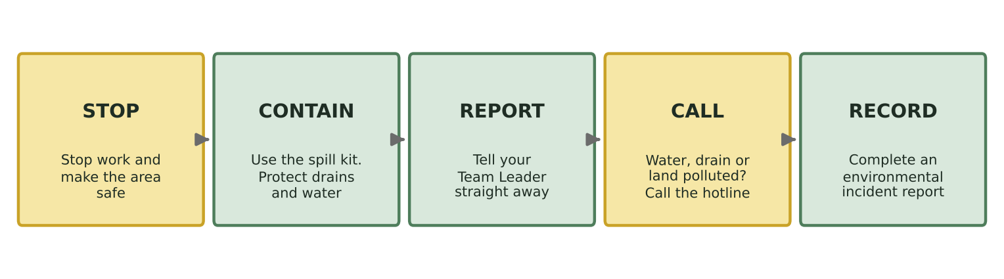
If pollution reaches – or could reach – a drain, watercourse or the ground, the Team Leader (or the most senior person on site) must report it straight away:
Nation | Who to call | 24-hour number
England | Environment Agency incident hotline | 0800 80 70 60
Wales | Natural Resources Wales incident line | 0300 065 3000
Scotland | SEPA – or report online. Overnight (6pm–8am) the line is for urgent, ongoing pollution only. | 0800 80 70 60
Northern Ireland | NIEA water pollution hotline | 0800 80 70 60

11. Competence and training records
We keep records of:
- environmental inductions (ARB-ENV-02)
- toolbox talk attendance (Toolbox Talk Register)
- site environmental briefings (job sheets and Site-Specific Risk Assessments)
- formal training and qualifications – full certificates, not just ID cards
- competence checks and refresher training (Training Dashboard, ARB-ENV-03).
Records are kept for at least [6] years after a person leaves, in line with our data protection and records retention arrangements. Training records contain personal data and must be stored securely.

12. Monitoring and review
We check this system is working through site and yard inspections, training records, toolbox talk attendance, incident investigations, client feedback, complaints and audits. How we do this is set out in the Environmental Monitoring, Review and Continual Improvement Procedure (ARB-ENV-05).
This document is reviewed at least once a year at the management review, and sooner if the law, our work, our clients' requirements or an incident shows it needs to change.

What this means for you
- Before you start with us, you'll have an environmental induction. Ask questions – there's no such thing as a silly one.
- Before every job, listen to the site briefing. If the Team Leader says there's a watercourse at the bottom of the garden, refuel on the drip tray at the van, not by the stream.
- Spot a nest, a bat, a badger sett or knotweed? Stop work in that area and tell your Team Leader. Nests are protected whenever they're in use – not just in spring.
- Knock over a fuel can? Stop, use the spill kit, protect the drain and tell your Team Leader straight away. Reporting quickly is what matters.
- Clean your boots, saw and kit before moving between sites – it stops tree diseases travelling with us.
- If your training is due, we'll book it. If you think you need more training, tell your Manager.

Record of amendments
Version | Date | Details of change | Amended by
[x.x] | [dd/mm/yyyy] | Full review and rewrite: plain-English content, current UK legal requirements checked, nation-specific information added, flowchart(s) and 'What this means for you' guidance added, linked to the environmental document set. | [NAME – ROLE]

Director sign-off
This document has been reviewed and approved by the Director(s). It will be reviewed at least once a year, and sooner if the law, our work, our clients' requirements or an incident shows it needs to change.
Signed
Name | [NAME]
Position | Director
Date | [dd/mm/yyyy]
Next review date | [dd/mm/yyyy]

