[COMPANY NAME Ltd]
Environmental Monitoring, Review and Continual Improvement Procedure
Document reference | ARB-ENV-05
Version | [x.x]
Date issued | [dd/mm/yyyy]
Next review date | [dd/mm/yyyy]
Document owner | [NAME – ROLE]
Approved by | [NAME – Director]

1. Purpose
This procedure explains how we check that our environmental controls are working, how we review our performance, and how we use what we learn to keep improving.
Regular monitoring shows us – and our clients, auditors and accreditation bodies – that we are doing what our Environmental Policy says, that we are meeting the law, and that problems are found and fixed before they cause harm. It is part of our Environmental Operations System (ARB-ENV-01).

2. Scope
This procedure covers all work carried out by or on behalf of [COMPANY NAME], including employees, subcontractors, Team Leaders, Managers and Directors, on client sites, at our yard and depot, and in our vehicles.

3. What we monitor and how often
The table below is our monitoring schedule. Frequencies in red are suggestions – set them to suit the size and type of your work.
What we check | How | How often | Who | Record
Environmental controls on site | Environmental inspection checklist – fuel, spill kit, waste, wildlife checks, briefings, permissions | [At least one per crew per month] | Team Leader | Environmental Inspection Checklist
Yard, depot and fuel store | Bunds and drip trays, fuel and oil containers, bowser locks, spill kits, waste and skips, drains | [Monthly] | Manager | Yard inspection checklist
Vehicle spill kits | Check each vehicle kit is complete and restocked | [Weekly] | Driver / Team Leader | Vehicle check sheet
Waste records | Transfer notes complete and filed; waste going to authorised sites only | [Monthly] | Office / Manager | Waste transfer note file
Registrations and permissions | Waste carrier registration, waste exemptions or authorisations, and other permits in date | [Quarterly] | Manager | Compliance Register
Legal compliance | Check we are meeting every requirement in the Compliance Register (evaluation of compliance) | [At least yearly] | Manager / Director | Compliance Register
Training and competence | Training Dashboard – overdue or due-soon training; toolbox talks delivered | [Monthly] | Manager | Training Dashboard; Toolbox Talk Register
Incidents and near misses | Investigate and record every environmental incident and near miss | As they happen | Team Leader / Manager | Environmental Incident Report; Corrective Action Log
Complaints and client feedback | Record and respond to any environmental complaint or comment | As received | Manager | Complaints log; Corrective Action Log
Fuel use | Track fuel bought (litres) to understand our carbon footprint and spot waste | [Quarterly] | Office / Manager | Fuel records
Subcontractors | Check environmental performance and registrations of subcontractors we use | [Yearly, and after any issue] | Manager | Approved Supplier and Subcontractor List
Environmental aspects and impacts | Review how our work affects the environment and whether controls are still right | [Yearly, or after significant change] | Manager / Director | Environmental Aspects and Impacts Register
Environmental Policy and this system | Management review | [Yearly] | Director(s) | Management review record

4. How we measure performance
We use the measures below to see whether we're improving. Targets in red are examples – agree your own at the management review.
Measure | Example target | This year's result
Pollution incidents reported to the authorities | [Zero]
Environmental incidents and near misses reported internally | [All reported within 24 hours] – more near-miss reports can show a healthy reporting culture
Environmental inspections completed against schedule | [100%]
Inspection actions closed by the agreed date | [90% or more]
New starters inducted before starting work | [100%]
Training up to date on the Training Dashboard | [95% or more]
Environmental toolbox talks delivered | [12 a year]
Waste transfer notes complete and filed | [100%]
Waste reused or recycled (e.g. woodchip, timber) rather than disposed of | [Set a baseline in year 1]
Fuel use per [£ of turnover / working day] | [Set a baseline, then reduce]
Environmental complaints | [Zero]

5. Dealing with problems: corrective action
When monitoring, an incident, a complaint or an audit shows something has gone wrong – or could go wrong – we deal with it like this:
- Make it safe. Stop the problem getting worse (for example, contain a spill or stop work near a nest).
- Record it on an Environmental Incident Report or inspection checklist, and add it to the Corrective Action Log.
- Investigate the root cause. Ask 'why?' until you find the real reason – for example, the spill kit wasn't restocked because nobody was responsible for checking it.
- Agree the corrective action, who will do it, and by when.
- Check the action has worked. If not, try again.
- Update procedures, risk assessments, training or the Environmental Aspects and Impacts Register if needed, and share the lessons learned at the next toolbox talk.
Serious pollution must also be reported to the relevant agency straight away (see section 9).

6. Continual improvement
Continual improvement means we don't just fix problems – we keep looking for better ways of working. The cycle below shows how it works.
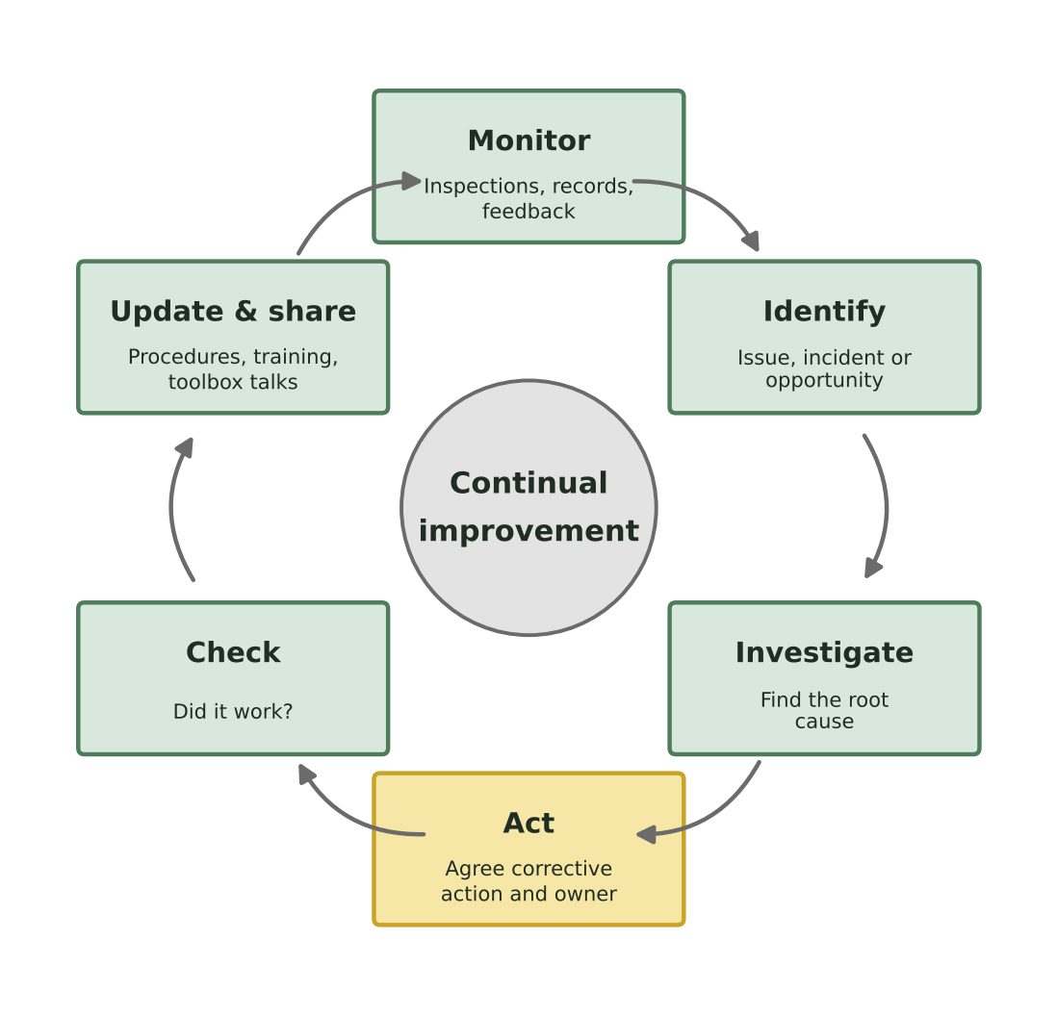
Improvement ideas can come from anyone. Examples for a tree surgery business include:
- switching to biodegradable chain oil or alkylate (low-emission) petrol
- moving to battery-powered saws and hedge cutters for suitable jobs
- finding more outlets for woodchip and timber so less goes to waste
- better journey planning to cut fuel use
- adding a missing item to vehicle spill kits after an inspection
- improving the site briefing after a near miss.

7. Environmental objectives
At the management review, the Director(s) set environmental objectives for the coming year. Objectives should be specific, measurable and have an owner and a deadline. Progress is checked at least every quarter.
Objective | How we'll achieve it | Owner | Target date | Progress
[Example: reduce fuel used per working day by 5% compared with last year] | [Journey planning; no idling; regular servicing; trial battery kit] | [NAME – ROLE] | [dd/mm/yyyy]
[Example: all vehicles carry a complete spill kit – checked weekly] | [Weekly check added to vehicle check sheet] | [NAME – ROLE] | [dd/mm/yyyy]

8. Management review
The Director(s) hold a management review at least once a year to decide whether our environmental system is working and what needs to change. The review is recorded (minutes or a review form) and actions go on the Corrective Action Log.

What the review looks at
- Actions from the last review
- Changes in the law, client requirements or accreditation standards (using the Compliance Register)
- Whether we are meeting our legal requirements
- Environmental incidents, near misses, complaints and investigation findings
- Inspection and audit results
- Performance measures and progress against objectives
- Training and competence (Training Dashboard and Annual Training Plan)
- Subcontractor environmental performance
- Changes to our work, equipment, sites or the risks we face – including climate and biodiversity issues such as storms, drought and new tree pests
- Resources needed and opportunities to improve.

What the review decides
- Whether the Environmental Policy and this system are still right, or need updating
- New environmental objectives for the coming year
- Training needs for next year's Annual Training Plan
- Resources, equipment or other actions needed, with owners and deadlines.

9. Reporting pollution
If pollution reaches – or could reach – a drain, watercourse or the ground, report it straight away to:
Nation | Who to call | 24-hour number
England | Environment Agency | 0800 80 70 60
Wales | Natural Resources Wales | 0300 065 3000
Scotland | SEPA (overnight line is for urgent, ongoing pollution only; otherwise report online) | 0800 80 70 60
Northern Ireland | Northern Ireland Environment Agency | 0800 80 70 60

10. Responsibilities
Who | Responsibilities
Directors | Provide resources; lead the annual management review; set objectives; approve improvement actions; make sure we meet our legal duties.
Managers | Run the monitoring schedule; carry out yard inspections and compliance checks; review inspection findings; manage the Corrective Action Log; update documents; report results to the Director(s).
Team Leaders | Carry out site environmental inspections; put controls in place; report incidents, near misses and concerns; deliver toolbox talks; suggest improvements.
Employees and subcontractors | Follow procedures; report incidents, near misses and concerns straight away; take part in inspections and investigations; suggest improvements.

11. Records
Record | Kept by | How long
Environmental inspection checklists (site and yard) | Office | [3 years]
Environmental incident reports and Corrective Action Log | Office | [6 years]
Waste transfer notes | Office | At least 2 years (legal minimum)
Hazardous waste consignment notes | Office | [3 years] – check current requirement
Management review records and objectives | Director(s) | [6 years]
Training records and Toolbox Talk Register | Office | [6 years after the person leaves]
Fuel and other performance records | Office | [6 years]
Set retention periods to match your records retention policy and any client or accreditation requirements.

12. Related documents
- Environmental Policy
- Environmental Operations System (ARB-ENV-01)
- Environmental Induction Checklist (ARB-ENV-02)
- Environmental Training Dashboard (ARB-ENV-03)
- Environmental Annual Training Plan (ARB-ENV-04)
- Compliance Register and Guidance Register
- Environmental Aspects and Impacts Register; Environmental Inspection Checklist; Environmental Incident Report; Corrective Action Log; Toolbox Talk Register
- Approved Supplier and Subcontractor List

What this means for you
- When your Team Leader does an environmental inspection on site, it's not about catching people out – it's about spotting problems before they turn into pollution or a fine.
- If you use the last absorbent pad in the spill kit, say so. A weekly check is only as good as the information people give it.
- Report near misses – like a fuel can left open next to a drain. They're free lessons.
- Got an idea – a better way to bag up arisings, a battery saw that would work well, a local outlet for woodchip? Tell your Team Leader. Good ideas get added to our objectives.

Record of amendments
Version | Date | Details of change | Amended by
[x.x] | [dd/mm/yyyy] | Full review and rewrite: plain-English content, current UK legal requirements checked, nation-specific information added, flowchart(s) and 'What this means for you' guidance added, linked to the environmental document set. | [NAME – ROLE]

Director sign-off
This document has been reviewed and approved by the Director(s). It will be reviewed at least once a year, and sooner if the law, our work, our clients' requirements or an incident shows it needs to change.
Signed
Name | [NAME]
Position | Director
Date | [dd/mm/yyyy]
Next review date | [dd/mm/yyyy]

