[COMPANY NAME] – COMPANY PROCEDURE
SERIOUS ACCIDENT INVESTIGATION PROCEDURE
How we investigate a serious accident, dangerous occurrence or high-potential near miss: quickly, fairly and thoroughly, so we find the real causes and stop it happening again.
Reference | Version | Date issued | Review date
ARB-PRO-05 | 2.0 | [DD/MM/YYYY] | [DD/MM/YYYY]

At a glance
What it is for | A thorough, no-blame investigation of serious events, with the evidence and report an insurer, HSE or client would expect.
Who does it | A Director leads, or appoints a Manager who was not involved. The Team Leader and H&S consultant help.
When (the trigger) | A medium or high level event (Section 1): e.g. a RIDDOR-reportable injury or dangerous occurrence, or a near miss that could have killed.
Time needed | Start within 24 hours. Most of the work is in the first week. Report within [10 working days]; actions tracked until closed.
You will need | INC-02, INC-03, the job pack, a camera, statement sheets (Section 6), insurer, consultant and solicitor contacts.
What “done” looks like | Root causes found; SMART actions done and checked; report shared; INC-01 closed.
Where records go | Restricted investigation folder, INC-01 and the ARB-POL-24 NC log. Keep [at least 3 years] (Section 5).

Where this fits in the incident system
1  Something happens  Respond: PRO-03 | › | 2  Report it the same day  INC-02 | › | 3  Manager logs it  INC-01 register (near misses too) | › | 4  Decide on RIDDOR  PRO-04 | › | 5  Investigate  INC-03; PRO-05 if serious  THIS PROCEDURE | › | 6  Record actions  INC-01 and POL-24 NC log | › | 7  Review trends  AUD-01; POL-01 s13
This procedure is step 5 for serious events. It runs alongside the INC-03 form: the form is the record, this procedure is how to do it well. The immediate response (PRO-03 and PRO-02) and the RIDDOR decision (PRO-04) come first.

The rule
Start within 24 hours, protect the evidence, and look for what in our system allowed it – not who to blame. After any serious incident the owner should take legal advice early, before the report is finished (Section 4.5).

1 Is it serious? Choose the level
Section 1 of 6 · About 2 minutes · Manager, Director
HSE’s guidance HSG245 sets four levels of investigation. Choose the level by the worst outcome that could reasonably have happened and how likely it is to happen again – not just by what did happen. A near miss can need a high-level investigation.
Level (HSG245) | Arb examples – tailor to your work | Who leads | Use
Minimal | Handsaw dropped from low height into a clear, coned-off zone. | Team Leader | INC-02; note in INC-01
Low | Minor cut from a hedge trimmer, first aid only; a scratched client’s gate. | Team Leader or Manager | INC-03
Medium | Over-7-day injury; a groundsperson hit by a rebounding limb; damage to a neighbour’s roof; a limb landing outside the drop zone near the public. | Manager, with the H&S consultant and an employee | INC-03 and this procedure
High | Death or specified injury (e.g. a fracture from a fall); contact with an overhead line; MEWP or lifting kit overturn or collapse; anyone hurt and taken to hospital from site; a near miss that could easily have killed. | Director, with the H&S consultant (and solicitor) | INC-03 and this procedure

2 Step by step
Section 2 of 6 · Day 1 to closure · Investigation lead
# | What to do | Who | Record it
1 | Start the investigation promptly – within 24 hours  Start within 24 hours to preserve witness memories and evidence. Record each step on the INC-03 form.  Appoint the investigation lead and team. The lead must not be someone whose own decisions are being looked at.  If you need to attend the scene, make sure it is still secured: nobody moves equipment or disturbs evidence (Section 4.1).  Contact the company-appointed H&S consultant for support: [name, phone]. | Director or Manager | INC-03 Section 1: lead, team, level, start date

2 | Tell the people who must know, and get advice  Confirm the RIDDOR decision and report in time (ARB-PRO-04).  Notify the insurer (employers’ liability, public liability or motor) and follow its instructions (Section 4.3).  Owner: take legal advice before the report is written (Section 4.5).  Name one person to deal with HSE, the police and the client (Section 4.4). | Director | INC-03 Section 7 notification log

3 | Gather and document all the evidence  Physical evidence: the scene, tools, PPE and equipment settings (e.g. rope lengths, anchor and friction device set-up, chipper feed control position). Photographs and environmental data (weather, light, ground).  Structured interviews, quickly and separately, with the injured party, the first aider, witnesses, the client (if required) and the Team Leader (Section 4.2).  Written records: method statements, risk assessments, training logs, equipment maintenance and LOLER records, and permits – especially those for the tree work being done. | Investigation lead; Team Leader | INC-03 Sections 3 to 6; evidence folder

4 | Analyse the findings and identify the causes  Sort causes into three kinds (HSG245):  - Immediate – what directly happened (e.g. the saw cut the lanyard).  - Underlying – unsafe acts and conditions, and system or procedural gaps (e.g. no second attachment).  - Root – the failure the others grew from (e.g. planning, training, supervision, culture).  Use proven methods such as the 5 Whys (Section 3) to get to the heart of the problem. | Investigation team | INC-03 Section 8

5 | Develop corrective and preventive actions (CAPA)  Clear actions that remove the causes: update training, procedures, equipment, site supervision or team communication. Use SMART criteria (Specific, Measurable, Achievable, Relevant, Time-bound) and give each action an owner.  e.g. “Site Manager to revise the aerial rescue checklist by [30 September].” | Investigation team; Director approves | INC-03 Section 9; register INC-01

6 | Report and share the findings  Write a clear report (outline in Section 6): event description, analysis, root causes and CAPA, photos or diagrams, and a short summary.  Update the Incident, Accident and Near Miss Register (INC-01) – this replaces the “Incident Spreadsheet in company drive”.  Share with senior management, the H&S consultant and the crew – without assigning individual blame, focused on preventing recurrence. | Investigation lead; Director signs off | Report in the investigation folder; INC-01; toolbox talk record

7 | Monitor and review effectiveness, then close  Track CAPA and check they worked – audits, toolbox talks, follow-up checks. Feed findings into risk assessments, method statements and training. Raise an ARB-POL-24 NC where relevant.  Close on the register (INC-01) once every action is done and checked. Trends go to the management review (ARB-AUD-01; ARB-POL-01 s13). | Manager; Director at review | INC-01 closed date; NC log; management review minutes

What this means for you
A groundsperson is hit by a limb that rebounds off a wall and breaks their forearm. The Team Leader follows PRO-03 and phones the Manager. The Manager confirms it is a specified injury and it is reported to HSE that day (PRO-04). By the next morning the Director has named the lead, told the insurer, called the H&S consultant and spoken to a solicitor. The lead photographs the rigging set-up before it is taken down, and interviews the climber, the groundsperson (once they are ready) and the Team Leader separately. The 5 Whys show that the site risk assessment did not cover rebound near hard surfaces. The actions go on INC-01, the crew hear the lessons at a toolbox talk without anyone being named, and the Manager checks the next three rigging jobs.

3 Finding the root cause: the 5 Whys
Section 3 of 6 · About 3 minutes to read · Investigation team
Start with what happened and ask “why?”. Each answer becomes the next question. Stop when you reach something in the system you can change. This example is generic; use your own facts.
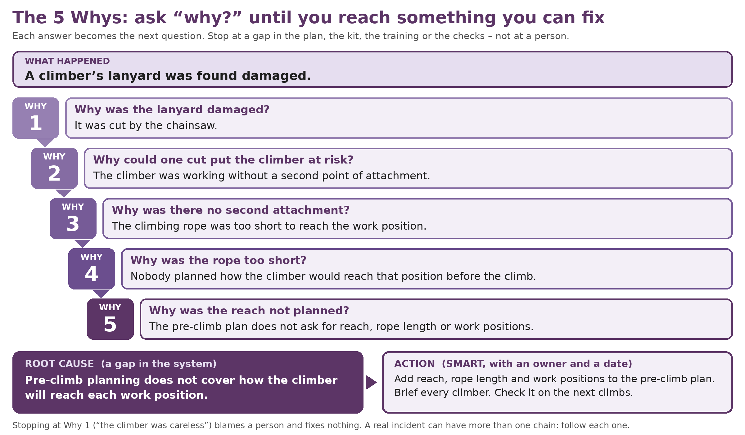
- Check each step with evidence – a statement, a photo, a record. If you cannot prove a step, say so.
- Look wider than one chain. Common root causes in tree work: job planning and pricing (time pressure), training and competence, supervision, kit inspection and maintenance, communication between climber and ground, and uncontrolled or out-of-date forms.
- Stop at a system gap, not a person. “Careless” and “human error” are not root causes: ask why the error was possible.

4 Duties during a serious investigation
Section 4 of 6 · About 6 minutes to read · Director, Manager, Team Leader

4.1 Preserving the scene
Do | Do not
Keep the area taped or coned off and a person at the edge until the investigation lead releases it. | Move, clean, repair or throw away anything, except to help someone or make it safe.
Photograph and video everything before anything is moved: wide shots, close-ups, set-up, PPE, ground and weather. Note the time. | Re-rig, re-climb or “test” the kit to see what happened. A competent person examines it later.
Quarantine the kit with a Do Not Use tag (ARB-EQ-013), bagged and labelled. Keep damaged PPE. | Let anyone take kit, phones or dashcam footage away without recording it.
Follow any direction from an HSE inspector or the police to leave things undisturbed (HSWA 1974 s20). | Restart work in that area until the Manager has assessed the risk (ARB-PRO-03).

4.2 Witness statements
- Talk to people separately and soon, somewhere quiet. Explain why: to learn, not to blame. They may have someone with them.
- Use open questions: “Tell me what you saw.” “What happened next?” Avoid leading questions such as “The rope was too short, wasn’t it?”
- Write down their words, then read it back. They check, sign and date it, and can have a copy. Use the template in Section 6.
- Do not interview someone who is injured, in shock or unwell until they are ready. Offer support first (ARB-POL-10).
- Record anything the client, public or other contractors saw, with their consent.

4.3 Insurers
- Tell your insurer promptly – employers’ liability for staff injuries, public liability for third parties and property, motor for vehicles. Check your policy for its notice terms.
- Follow the insurer’s instructions, including anything it says about admitting fault or talking to the injured party’s representatives. Keep the claim reference on INC-03.

4.4 HSE inspectors and the police
- Name one person to deal with HSE and the police: [Director name]. Be polite, co-operative and factual.
- Inspectors can enter, direct that things are left undisturbed, take photos, measurements and samples, take possession of articles, inspect and copy documents, and require people to answer questions and sign a declaration (HSWA 1974 s20). Keep a log of what was asked for, given or taken, with receipts.
- After a work-related death, HSE and the police work together under the Work-related Deaths Protocol, which decides who leads the investigation.
- If HSE finds a material breach and writes to you (a notification of contravention), it can charge a Fee for Intervention for its time. Any request to interview someone under caution, or any notice served, needs legal advice straight away.

4.5 Legal advice and confidentiality
- After a serious incident the owner should take legal advice early – ideally before the investigation report is written. Your insurer may provide a solicitor.
- Whether an investigation report can be kept confidential (legal privilege) depends on why and how it was prepared. Your solicitor will advise. This procedure does not give legal advice.
- Keep investigation papers in the restricted folder. Only the Director shares them outside the company. Nobody posts about the incident on social media (ARB-POL-33).
Stop – do not continue if…
- an HSE inspector or the police have asked for the scene or kit to be left undisturbed, and have not released it;
- someone is asked to be interviewed under caution, or a notice is served – get legal advice first;
- the injured person, or a witness, is not well enough to talk – support them and wait;
- the investigation lead was involved in the decisions being looked at – appoint someone else;
- you are about to return quarantined kit to use before a competent person has examined it.
If any of these apply, stop and speak to [Director name] before you go further.

5 Records and evidence
Section 5 of 6 · About 1 minute · Office, Director
What to keep | Where | How long | Why
Investigation form (INC-03), report, statements, photos, sketches | Restricted investigation folder | [At least 3 years; ask your insurer] | RIDDOR record keeping; claims; learning
RIDDOR report copy and HSE reference | Investigation folder; INC-01 | At least 3 years | RIDDOR 2013 regulation 12
Log of HSE and police contact, and items taken | Investigation folder | As the report | Shows what was given and when
Insurer and solicitor correspondence | Director’s restricted file | [As advised by your solicitor] | Claims; confidentiality
CAPA and close-out checks | Register INC-01; ARB-POL-24 NC log | [6 years] | Evidence the actions were done and worked (audits, tenders)
Quarantined kit records | ARB-EQ-000 defect log | Life of the kit | Shows what was examined, repaired or retired

6 Templates
Section 6 of 6 · Copy, paste and fill in · Investigation lead, Director
Witness statement
Incident code: [INC-YYYY-NNN] Name: ______________ Role / company: ______________ Phone: ______________
Date, time and place of this statement: ______________ Taken by: ______________
“I was … (where you were and what you were doing). I saw / heard … Then … After that …”
Write in the person’s own words, in the order things happened. Include what they saw, heard and did – not what they think caused it, unless they want to add that at the end.
I have read this statement (or had it read to me) and it is true to the best of my knowledge. Signed: ______________ Date: ______________

Insurer notification (email)
Subject: Incident notification – [policy number] – [date of incident]
We are notifying you of an incident on [date] at [site] involving [an employee / a member of the public / property]. [One or two factual sentences.] It [has / has not] been reported to HSE under RIDDOR ([HSE reference]). We are investigating and will follow your instructions. Please confirm the claim reference and who will handle it. Contact: [name, phone].
Facts only. Do not give opinions on cause or fault in this email.

Investigation report outline
- Summary (half a page): what happened, the main causes, the key actions.
- Event description: date, time, place, people, task, sequence of events, sketch and photos.
- Analysis: evidence reviewed; immediate, underlying and root causes; 5 Whys.
- CAPA: SMART actions with owner, due date and how we will check they worked.
- Sharing and follow-up: who has seen it, the toolbox talk date, and the review date.
- Appendices: INC-02, INC-03, statements, photos, records.

Guidance for the business owner – remove before issue
What we checked (checked 28/09/2026). Auditors, insurers and principal contractors expect a written investigation with root causes and close-out (MHSWR 1999 regulation 5; ARB-POL-01 12.4 and 13).
- HSE HSG245 “Investigating accidents and incidents” (2004) is still listed as current on hse.gov.uk. It sets four steps, three kinds of cause and four levels (minimal, low, medium, high) chosen by potential consequences and likelihood of recurrence. It says start “as soon as possible” and that “blaming individuals is ultimately fruitless”. The 24-hour start is your company rule.
- RIDDOR 2013: deaths, specified injuries, dangerous occurrences and non-workers taken to hospital – notify without delay by the quickest practicable means, report received within 10 days; over-7-day injuries within 15 days; diseases on diagnosis; records at least 3 years. HSE’s out-of-hours duty officer (0151 922 9235) is only for a work-related death or a serious incident with multiple casualties or major disruption. Full detail: ARB-PRO-04.
- RIDDOR review: HSE consulted from 7 April 2026 (its press release says it closed 30 June 2026; the consultation hub shows 7 July 2026). No response has been published and no new regulations made. Do not change your practice until HSE publishes the outcome.
- HSE powers and costs: HSWA 1974 section 20 (inspectors’ powers); HSE Fee for Intervention applies where an inspector finds a material breach and writes to you. HSE and the police follow the Work-related Deaths Protocol after a death.
Your decisions. (1) H&S consultant, insurer and solicitor contacts (Section 2; ARB-PRO-02). (2) Who leads each level, and the Section 1 examples. (3) Report target (we suggest 10 working days). (4) Retention (Section 5). (5) Who speaks to the press (we suggest a Director only).
Changes from your original. All six stages and every point kept; the incident spreadsheet is now the register (INC-01). The third-party 5 Whys graphic is replaced with an original one. Added: levels, notifications, investigation duties, stop box, example, records and templates.
Arborella provides this template as documentation support. It is not legal advice or technical arboricultural advice. After a serious incident, your solicitor, insurer and competent H&S adviser come first.

Related documents
Reference | Document
ARB-POL-01 | Health and Safety Policy (12.4 accidents and RIDDOR; 13 monitoring and review)
ARB-PRO-02 / 03 / 04 | Emergency Procedures and Contacts; Immediate Accident Response Process; RIDDOR Reporting Procedure
ARB-INC-01 / 02 / 03 | Incident, Accident and Near Miss Register; Incident and Near Miss Report; Accident and Incident Investigation Form
ARB-POL-10 / 24 / 33 | Mental Health, Wellbeing and Fatigue; Quality Policy (NC log); IT, Communications and Monitoring
ARB-AUD-01; ARB-EQ-000 / 013 | Office and Management Audit; Equipment Defect Report and Log; Do Not Use Tags

Document control
Document | Serious Accident Investigation Procedure (ARB-PRO-05)
Owner | Company Director
Approved by | [Name, role]
Status | Controlled template – Live once approved
Review | At least every 12 months, and sooner if the law, guidance or the way we work changes

Ver. | Date | Author | Summary of changes
1.0 | 01/07/2026 | Arborella Consultancy Ltd | Initial release
2.0 | 28/09/2026 | Arborella Consultancy Ltd | Renumbered ARB-PRO-05; company procedure layout. All stages kept. Added levels, duties, original 5 Whys graphic, records and templates.

