[COMPANY NAME] – SITE FORM
SITE SPECIFIC RISK ASSESSMENT AND CREW BRIEFING
Filled in by the Team Leader on site, on the day, before work starts: today’s hazards and controls, the emergency and rescue plan, and who has been briefed.
At a glance
What it is for | Assessing, controlling and briefing the risks on this site today. | Who fills it in | The Team Leader, with the crew. Everyone signs section 8.
When | On arrival, before unloading saws. Review if anything changes. | Time needed | About 20–30 minutes, with the briefing.
You will need | Job Sheet, Method Statement, GRAs, COSHH sheets, phone. | Where it goes | Job pack. Keep for [at least 3 years].
Reference | ARB-SITE-004 · Version 2.2 | Job reference | [JOB REF]

Where this fits | Survey & Quote → | Job Sheet → | Site Specific Risk Assessment + Method Statement → | Wildlife check → | Work → | Job completion
Use with the Method Statement (ARB-SITE-005) for this job. Wildlife check: ARB-SITE-006.
How to fill this in
1 | Walk the site first. Fill in sections 1 to 5 before anyone unloads a saw or leaves the ground.
2 | Write the hazards and controls in section 6. Use the prompts. If a hazard cannot be controlled, do not start – ring your Manager.
3 | Brief everyone with this form, including visitors and subcontractors. Everyone signs section 8.
4 | If anything changes, stop and re-assess. Record it in section 9. Close out in section 10.

1 | Site and job details Section 1 of 10 · About 3 minutes · Team Leader
Client name |  | Date of assessment | DD/MM/YYYY
Site address |  | Postcode

what3words | ///word.word.word | Grid reference | optional, rural sites
Job Sheet ref. |  | Survey / Quote ref. | if applicable
Method Statement ref. |  | Team Leader
Work today | e.g. dismantle ash over garage roof, rig limbs to ground, chip on the drive, grind the stump

HAVE YOU TAKEN BEFORE PHOTOS?  Whole site, each tree, the access route and any existing damage (e.g. cracked paving, broken fence panel). Photos protect you if there is a complaint or claim. | ☐ Yes  Saved to: [job folder / app]

2 | Emergency information Section 2 of 10 · About 4 minutes · Team Leader
999 or 112 | Manager (name, mobile) |  | Office |  | 105 power cut or damaged line
Emergency services | Client contact |  | Network operator (if lines) |  | 0800 111 999 gas

Ambulance meeting point | e.g. front gate, Mill Lane – someone waits there | what3words (meeting point) | ///
Road name and access | gate code, width, 4x4 only? | Helicopter landing area | if remote, e.g. field north of the yard
Nearest A&E | name, postcode, drive time – a full A&E, not a minor injuries unit | Nearest phone signal | e.g. top of the drive

Check | Tick | Details
Phone signal here | ☐ Good ☐ Poor ☐ None | If poor or none, fill in the next row
No-signal plan (ARB-POL-22)  Who calls 999, and how? | ☐ Office told ☐ Radios ☐ Satellite device | Check-in time with the office:
First aiders on site | ☐ EFAW+F or equivalent | Names:
First aid and bleed kit, extinguisher, spill kit | ☐ All on site | Where? e.g. passenger side of the tipper
Welfare | ☐ Arranged | e.g. client’s cloakroom by agreement; water in the van

3 | Planning and ecology checks Section 3 of 10 · About 3 minutes · Team Leader
Check | Tick | Details
Tree Preservation Order (TPO)? | ☐ Yes ☐ No ☐ Unknown | If yes: consent reference and date
Conservation Area? | ☐ Yes ☐ No ☐ Unknown | If yes: notice reference and date

Felling licence needed?  England: Forestry Commission, unless an exception applies | ☐ Licence in pack ☐ Exception recorded ☐ No felling | Which exception, and the evidence
Wildlife check (ARB-SITE-006) done today?  nesting birds, bats, badgers, other protected species | ☐ Yes ☐ Not needed | Signed by:
Wildlife found? | ☐ No ☐ Yes – stopped | If yes, follow ARB-SITE-006 before any work
Other constraints  e.g. hedgerow cutting season, SSSI, watercourse, tree protection fencing | ☐ None ☐ Yes | Details

Unknown is not a yes to go. Do not work on a tree that may be protected until the office confirms consent or an exception is in the job pack (ARB-POL-29).

4 | Work at height and rescue Section 4 of 10 · About 4 minutes · Team Leader and climber
Work at height today? | ☐ Yes ☐ No – go to section 5
Access method | ☐ Climbing ☐ MEWP ☐ Ladder ☐ Ground only ☐ Crane | Ladder: short, low-risk tasks only

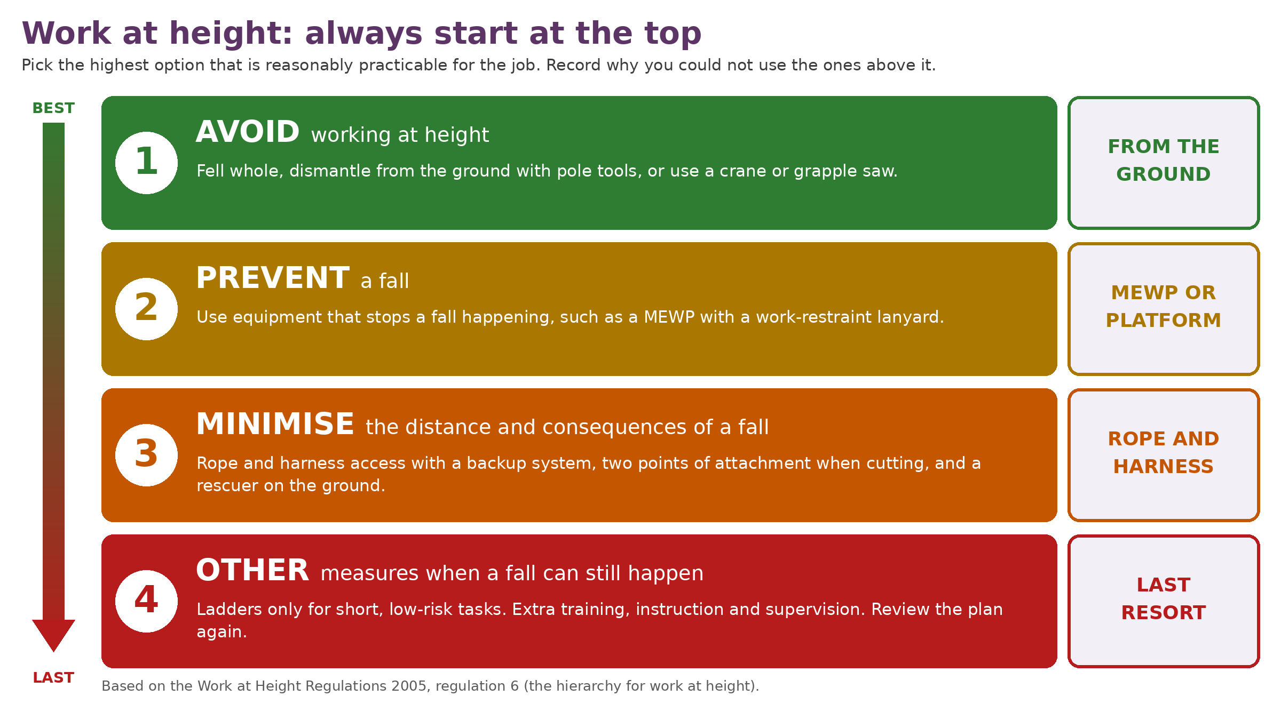 | Level used today  ☐ 1 Avoid ☐ 2 Prevent  ☐ 3 Minimise ☐ 4 Other  Why not a safer level?  e.g. no MEWP access – soft lawn and a 1.1 m side gate; crane not viable over the house

Before anyone leaves the ground – tick, or write N/A
☐ Climbing: backup system, two anchor points when cutting  ARB-POL-01 section 7.2 | ☐ Climbing: anchors checked from the ground and aloft
☐ Climbing and rigging kit checked, in LOLER date  ARB-EQ-007 / ARB-EQ-010 | ☐ MEWP: operator certificate for this type  e.g. IPAF, NPTC
☐ MEWP: firm ground, pads down, wind within limit  limit on the plate: | ☐ MEWP: ground person knows the emergency lowering controls

Rescue plan
Aerial rescuer (name) | on the ground and ready | Certificate checked | e.g. aerial rescue, date
Second rescuer / helper |  | Rescue kit is at | e.g. base of the ash, on the tarp
How we will rescue | e.g. rescuer climbs on own system, transfers casualty and lowers to the ground. MEWP: lower from the ground controls.

☐ Rescue kit set up and checked before the climb | ☐ Rescue plan briefed to the whole crew | ☐ First aid and bleed control kit at the tree

No aerial rescuer, no climb
At least 2 people must be on site for any aerial work, and one person on the ground must be competent, equipped and ready to rescue without delay. Never attempt a rescue if the casualty may be in contact with a live power line. Keep clear, call 999 and 105.

5 | Overhead lines and underground services Section 5 of 10 · About 3 minutes · Team Leader
Check | Tick | Details
Overhead lines within 2 tree lengths, or 10 m, of the work?  Measure 10 m sideways at ground level from the nearest wire. Count anything a falling tree, limb, rope or machine could reach. | ☐ No ☐ Yes: ☐ power on poles ☐ pylons ☐ phone / data | Nearest distance: m
Power line: network operator consulted, method agreed?  shutdown, permit or line guarding | ☐ Yes ☐ N/A | Who, date, reference

Lines pointed out to everyone on site? | ☐ Yes ☐ N/A
Breaking the ground today?  e.g. stump grinding, posts, outriggers, planting | ☐ No ☐ Yes
If yes: service plans and CAT and Genny scan  e.g. LinesearchbeforeUdig; scan by a trained person | ☐ Plans ☐ Scanned | Scanned by:
Client permit to dig / services marked | ☐ Permit ☐ Marked ☐ N/A | Permit no. / where

Overhead power lines – our rules (ARB-POL-01 section 10.2)
No felling within 2 tree lengths of an overhead power line, and no work where any part of the tree, equipment or a person could come within 10 m of a live line, until the Team Leader or a Director has consulted the network operator and a safe method is agreed. If in doubt, stop.

6 | Hazards and controls Section 6 of 10 · About 8 minutes · Team Leader with the crew
Who? C = crew P = public R = client or residents V = visitors and other contractors. For each hazard, write what is actually here today and the controls you will use. The grey prompts are examples – tick the ones you use and add your own. Tick In place? once the control is set up.
Cannot control it? Do not start.
If you cannot put a control in place for a hazard, or you are not sure the controls are enough, stop and ring your Manager before work starts. Record what was agreed in section 9.

Hazard | What is here today? | Who? | Controls – tick what you are using, add your own | In  place?
THE TREE AND THE WORK  Tree condition | e.g. decay, cracks, fungi, deadwood, hangers, storm damage |  | ☐ Inspected from the ground before anyone climbs ☐ Cut plan suits the condition ☐ Weak or dead tree: MEWP or fell | ☐
Felling direction | e.g. lean, weight, targets, escape routes |  | ☐ Direction agreed with the crew ☐ Two escape routes cleared ☐ 2 tree lengths clear ☐ Wedges, winch or pull line | ☐
Drop zones and exclusion zones | e.g. falling timber, rigging, chipper, grinder |  | ☐ Zone marked: cones, tape, signs ☐ Entry points watched ☐ "Stand clear" call and reply before every cut | ☐
Rigging and lowering | e.g. shock loads, anchor failure, crush |  | ☐ Rigging plan (Method Statement) ☐ Kit in LOLER date ☐ Anchor checked ☐ Ground crew out of the bight | ☐
Chainsaws and machinery | e.g. cuts, kickback, hot parts |  | ☐ Certificated operators ☐ Pre-use checks done ☐ Full chainsaw PPE ☐ Bleed control kit to hand | ☐
Chipper feeding | e.g. drawn in, kickback of material, blockages |  | ☐ Feed from the side ☐ Stop bar tested ☐ No loose cuffs or cords ☐ Never reach into the hopper ☐ Engine off, key out to clear | ☐
Stump grinder debris | e.g. flying chips and stones, buried services |  | ☐ Exclusion zone set ☐ Guards and debris screens in place ☐ Services checked (section 5) ☐ Visor worn | ☐
Manual handling | e.g. heavy rounds, dragging brash |  | ☐ Cut to a manageable size ☐ Team lifts or mechanical aids ☐ Clear route for dragging | ☐
THE SITE  Traffic, vehicles and road users | e.g. road, footpath, drive, car park |  | ☐ Signs, lights and guarding ☐ Traffic management plan on the highway ☐ Safe pedestrian route | ☐
Members of the public and neighbours | e.g. children, dogs, parked cars |  | ☐ Neighbours told ☐ Barriers and signs ☐ Stop work if anyone comes near | ☐
Uneven ground, slopes, steps | e.g. wet grass, banks, holes |  | ☐ Trip hazards cleared ☐ Plant only on stable ground ☐ Ground protection mats | ☐
Overhead and underground services | See section 5 |  | ☐ Section 5 completed ☐ Lines and services pointed out to everyone | ☐
Property and structures | e.g. roof, glasshouse, fence, car |  | ☐ Protected or moved ☐ Existing damage photographed ☐ Rig pieces near structures – do not drop | ☐
CONDITIONS AND PEOPLE  Weather and wind limits | e.g. gusts, rain, ice on limbs, heat, lightning |  | ☐ Forecast checked ☐ Stop climbing / MEWP above [company wind limit] or the MEWP maker’s limit ☐ Come down in lightning | ☐
Lone working | e.g. surveying, clearing up at the end |  | ☐ No chainsaw, climbing, chipping or grinding alone ☐ Check-in plan agreed (ARB-POL-22) | ☐
Fatigue | e.g. long days, call-outs, travel, heat |  | ☐ Breaks planned ☐ Asked: anyone too tired to climb, cut or drive? ☐ Swap tasks or stop | ☐
Noise | e.g. saws, chipper, grinder, blower |  | ☐ Hearing protection zone ☐ Ear defenders worn ☐ Chipper sited away from homes | ☐
Vibration (HAVS) | e.g. long saw or grinder use |  | ☐ Low-vibration tools ☐ Trigger time tracked ☐ Tasks rotated ☐ Hands warm and dry | ☐
Biosecurity | e.g. known pest or disease, Plant Health Notice |  | ☐ Arrive clean, leave clean ☐ Biosecurity Plan (ARB-SITE-007) if needed | ☐
Wildlife: bats, nesting birds | See section 3 |  | ☐ Wildlife check (ARB-SITE-006) done ☐ Stop if found, tell the Team Leader | ☐
Substances (COSHH) | See section 7 |  | ☐ COSHH and SDS in the van ☐ Refuel on a drip mat, away from drains ☐ Spill kit to hand | ☐
OTHER HAZARDS HERE  Other: | e.g. water, asbestos, needles, wasps, giant hogweed |  |  | ☐
Other: |  |  |  | ☐

7 | Assessments, substances and PPE Section 7 of 10 · About 4 minutes · Team Leader
Generic Risk Assessments that apply – I have reviewed these for this job
☐ Ground-based tree work | ☐ Aerial tree work (climbing) | ☐ Felling
☐ Rigging and lowering | ☐ MEWP use | ☐ Ladders and steps
☐ Wood chipping | ☐ Stump grinder | ☐ Hedge trimming
☐ Hand tools | ☐ Manual handling | ☐ Noise
☐ Vibration | ☐ Traffic management | ☐ Driver and road safety
☐ Watercourses | ☐ Pesticide use | ☐ Lone working
☐ Worksite common hazards | ☐ Other: | ☐ GRA references: [add yours]

Substances on site (COSHH)
Substance on site | In use today |   Flammable |   Serious health hazard |   Harmful or irritant | 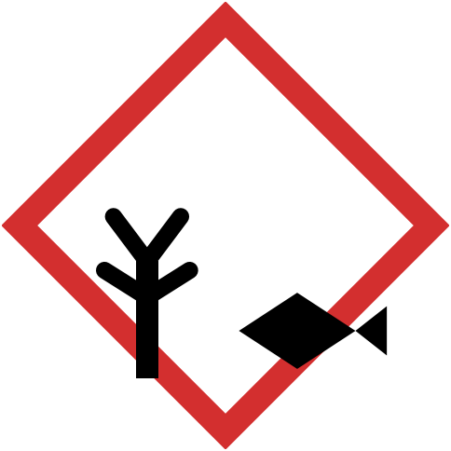  Harms the environment | COSHH and SDS read | Where stored / notes
Petrol | ☐ | ☐ | ☐ | ☐ | ☐ | ☐
2-stroke mix | ☐ | ☐ | ☐ | ☐ | ☐ | ☐ | label the can
Alkylate / bio 2-stroke | ☐ | ☐ | ☐ | ☐ | ☐ | ☐
Diesel | ☐ | ☐ | ☐ | ☐ | ☐ | ☐
Chain oil (mineral) | ☐ | ☐ | ☐ | ☐ | ☐ | ☐
Bio chain oil | ☐ | ☐ | ☐ | ☐ | ☐ | ☐
Hydraulic oil | ☐ | ☐ | ☐ | ☐ | ☐ | ☐
Grease / copper grease | ☐ | ☐ | ☐ | ☐ | ☐ | ☐
Antifreeze / coolant | ☐ | ☐ | ☐ | ☐ | ☐ | ☐
Herbicide – glyphosate | ☐ | ☐ | ☐ | ☐ | ☐ | ☐ | [product]
Other herbicide or pesticide | ☐ | ☐ | ☐ | ☐ | ☐ | ☐ | [product]
Disinfectant (biosecurity) | ☐ | ☐ | ☐ | ☐ | ☐ | ☐ | [product]
Biological hazards | ☐ | n/a | n/a | n/a | n/a | ☐ | wood dust, spores, ticks
Other: | ☐ | ☐ | ☐ | ☐ | ☐ | ☐
Tick the symbols printed on the label or safety data sheet (SDS) of the product you actually have. Another symbol, such as corrosive? Write it in the notes. Pesticides are used only by certificate holders.
PPE needed today – check everyone has it and it is in good condition
☐ Helmet, visor and ear defenders | ☐ Safety glasses or goggles | ☐ Chainsaw trousers or chaps
☐ Chainsaw boots | ☐ Chainsaw gloves | ☐ Work gloves
☐ Chemical-resistant gloves | ☐ Hi-vis (class for the road) | ☐ Dust mask (e.g. FFP3)
☐ Harness and fall protection | ☐ Face shield (chipper, grinder) | ☐ Waterproofs and warm layers
☐ Sun protection | ☐ Lifejacket or buoyancy aid | ☐ Other:

8 | Crew briefing and sign-on Section 8 of 10 · About 5 minutes · Team Leader briefs, everyone signs
Briefing covered – tick each topic
☐ The work and the order we will do it | ☐ Exclusion zones and drop zones | ☐ Hazards and controls (section 6)
☐ Emergency plan and meeting point | ☐ Rescue plan and aerial rescuer | ☐ Lines and services
☐ Wildlife and biosecurity | ☐ Radios or hand signals | ☐ Welfare and breaks

By signing, I confirm: I have been briefed on this plan and the Method Statement. I understand the controls, the emergency and rescue plan, and my role. I know anyone can stop the job if they think it is unsafe. I have told the Team Leader if I am unwell, overtired or on medication that could affect my work.
Name (print) | Role, or company if not ours | Certificates checked | I under-stand the plan | Signature | Time in / out
 | e.g. Climber, Aerial rescuer | e.g. chainsaw, climbing, EFAW+F | ☐
 |  |  | ☐
 |  |  | ☐
 |  |  | ☐
 |  |  | ☐
 |  |  | ☐
 | Visitor or subcontractor |  | ☐
 | Visitor or subcontractor |  | ☐

Team Leader | Name | Signature | Date | Time briefed

9 | Dynamic review and stop work Section 9 of 10 · Through the day · Team Leader
Something changed? Stop, re-assess, tell the crew, record it here. If you cannot control the new hazard, ring your Manager first.
Job running more than one day? From day 2, use the SSRA Daily Review (ARB-SITE-012) instead of a new SSRA – unless there is a big change.
Time | What changed | New controls | Crew told | Initials
 | e.g. gusts rising; climber finds cavity in upper stem | e.g. stopped climbing, finish from MEWP tomorrow. Manager agreed 11:20 | ☐
 |  |  | ☐
 |  |  | ☐

STOP WORK IF…
Anyone can stop the job, without blame. Make it safe, tell the Team Leader, record it above.
■ Wind or lightning goes past our limits | ■ Anyone enters the exclusion zone | ■ The aerial rescuer or rescue kit is not ready
■ The tree is not what we expected | ■ We find nesting birds, bats or other wildlife | ■ A line or service is closer than planned
■ Kit is damaged or not working | ■ Someone is too tired, unwell or unsure | ■ Radios or signals stop working

10 | End of day close-out Section 10 of 10 · About 5 minutes · Team Leader
☐ Site left safe: no hangers, stumps flush or marked | ☐ Everyone accounted for and signed out | ☐ Tools, fuel, waste removed (transfer note)
☐ Kit and vehicles cleaned (biosecurity) | ☐ Defects reported (ARB-EQ-000) | ☐ Accidents or near misses reported
☐ Client told work is complete, or site walked with them | ☐ Anything left for the next visit recorded | ☐ Lessons for next time noted below

HAVE YOU TAKEN AFTER PHOTOS?  Same views as before, plus the stump, the clean-up and any damage.  ☐ Yes | Notes and lessons  e.g. side gate too narrow for the chipper – note it on the survey for next year’s visit

Closed out by | Team Leader name | Signature | Date | Time finished

Guidance for the business owner – remove before issue
Why this form matters. The Management of Health and Safety at Work Regulations 1999 (regulation 3) require a suitable and sufficient risk assessment, recorded if you have 5 or more employees. The Work at Height Regulations 2005 require work at height to be properly planned, including emergencies and rescue (regulation 4), following the hierarchy in regulation 6. HSE tree work guidance says a minimum of 2 people must be present during all aerial work, and one of the ground team must be available, competent and equipped to do an aerial rescue without delay (HSE "Aerial work", checked 27/09/2026).
Overhead lines and services. HSE advises getting advice from the network operator before working within 10 m of overhead power lines, measured horizontally at ground level from the nearest wire, and considering work further away that could breach that distance (HSE "Working near power lines and cables", checked 27/09/2026). The 2 tree lengths rule for felling is your company rule in ARB-POL-01 section 10.2, based on FISA 804. Underground services: HSE HSG47. The 105 and gas emergency numbers match ARB-POL-01; check them each year.
Emergency and first aid. HSE tree work first aid guidance asks you to record grid references or GPS coordinates and access points, to allow for how remote the site is, and lists haemostatic dressings and a tourniquet for personal first aid kits (HSE "First aid and emergency procedures", checked 27/09/2026). Your first-aid needs assessment and ARB-POL-01 section 12 set your own standard, for example EFAW+F.
No scoring on site. This form deliberately does not ask crews to score risk (likelihood × severity). The law needs a suitable and sufficient assessment – the hazards, who could be harmed and the controls – not a number (MHSWR 1999 regulation 3; HSE "Managing risks and risk assessment at work"). Risk scoring stays in your Generic Risk Assessments and ARB-POL-02 Risk Management. On site, the rule is simple: if a hazard cannot be controlled, do not start and ring the Manager. Decide how a Manager agrees changes from site, for example by phone, recorded in section 9 with the time and name.
Tailor it. Add your GRA references (section 7) and product names. Set your company wind limit (section 6): there is no single legal figure, so base it on your GRAs, the Arboricultural Association Tree Work at Height Code of Practice and the MEWP maker’s limit. Delete rows that never apply to your work. The retention period on page 1 is a suggestion: keep forms longer after any accident, claim or complaint.
Link it. ARB-POL-01 Health and Safety (sections 5.1, 7, 10 and 12), ARB-POL-02 Risk Management, ARB-POL-13 Biosecurity, ARB-POL-17 Emergency Call-Out, ARB-POL-22 Lone Working, ARB-POL-29 Tree Protection, ARB-SITE-005 Method Statement, ARB-SITE-006 Wildlife check, ARB-SITE-007 Biosecurity Plan, ARB-SITE-012 SSRA Daily Review (day 2 onwards on multi-day jobs).
What auditors look for. An assessment done on site on the day (not a copy of the generic one), signed by everyone on site, a named aerial rescuer, evidence of dynamic review, and a close-out. Keep it in the job pack with the photos.
Arborella provides this template as documentation support. It does not replace a competent person’s judgement on site, your generic risk assessments, or specialist advice.

Related documents
Reference | Document
ARB-POL-01 | Health and Safety Policy
ARB-POL-02 | Risk Management Policy (risk scoring for Generic Risk Assessments)
ARB-POL-22 | Lone Working Policy
ARB-SITE-005 | Method Statement (RAMS)
ARB-SITE-006 | Wildlife and Protected Species Check
ARB-SITE-007 | Site Biosecurity Plan
ARB-SITE-012 | SSRA Daily Review (Day 2 onwards)
[ref] | Generic Risk Assessments and COSHH assessments

Document control
Document | Site Specific Risk Assessment and Crew Briefing (ARB-SITE-004)
Owner | Company Director
Approved by | [Name, role]
Status | Controlled template – Live once approved
Review | At least every 12 months, and sooner if the law, guidance or the way you work changes

Ver. | Date | Author | Summary of changes
1.0 | 01/10/2026 | Arborella Consultancy Ltd | Initial release

