COMPANY - COSHH ASSESSMENT
BRACKEN
Assessment status | Document control
Hazard-specific assessment - confirm site exposure | Reference: AOS-BIO-15 | Version: 1.0
Applies to | Assessment date: ____ / ____ / ______
Arboriculture, forestry, grounds maintenance and outdoor work | Review date: ____ / ____ / ______

1. Hazard identification
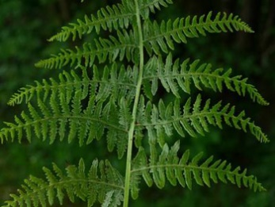 | 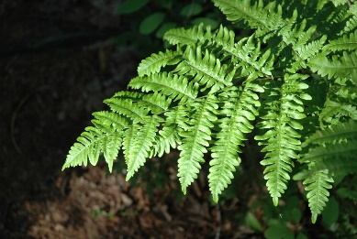
Identification photographs retained from supplied SBust reference.
Hazard | Details
Common name | Bracken
Organism / botanical name | Pteridium aquilinum
Where encountered | Heath, woodland, moorland and unmanaged ground; spores are released seasonally.
Persons potentially exposed | Employees, climbers, grounds staff, trainees/apprentices, contractors, visitors and the public if controls fail

2. Warning symbols
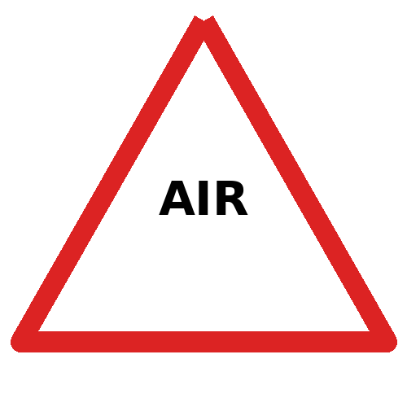
Airborne irritant/allergen
Naturally occurring biological or plant hazard; chemical CLP pictograms normally do not apply. The symbols used here are workplace warning and PPE symbols.

3. Exposure routes and health effects
Exposure routes | Potential harm
Skin/eye contact with sap or dust; inhalation of spores/dust | Skin/eye irritation and respiratory symptoms; Bracken is toxic if eaten by livestock; avoid unnecessary exposure to dense spores
Initial risk | Residual risk after controls | Health surveillance
High | Low | Review need with competent occupational-health advice where exposure is regular, sensitisation is possible or symptoms are reported.

4. Required controls
- Check client/site information and survey for this hazard before work. Record presence, extent, affected tasks and controls in the SSRA.
- Avoid large-scale cutting in dry/spore-heavy conditions where practicable
- Use machinery/cab or work upwind; minimise dust
- Do not eat or smoke; wash and prevent contaminated clothing entering welfare areas
- Use tools or mechanical methods to avoid direct contact where reasonably practicable. Maintain an exclusion zone where material could spread, project or expose others.
- Do not eat, drink or smoke in the exposure area. Keep contaminated PPE/equipment away from vehicles, climbing equipment and welfare areas.
- Provide soap-and-water handwashing and clean/decontaminate tools, boots and PPE without spreading contamination.
- Stop work and inform the Team Leader if the hazard is unexpected, identification is uncertain or controls cannot be achieved.

5. Mandatory / task-selected PPE
  Protective gloves |   Eye protection |   Suitable RPE |   Coveralls / covered skin |   Hand washing
PPE selection must match the task and exposure level. RPE is only effective when correctly selected; tight-fitting RPE requires face-fit testing, a clean-shaven seal, training, inspection and replacement. PPE does not replace avoidance, mechanical control or exclusion.

6. Emergency and first aid action
- Move to fresh air; wash skin and flush eyes
- Seek medical advice for persistent breathing, eye or skin symptoms
- Report the exposure, injury, symptoms or near miss promptly and record the site, task, time and suspected agent.
- Call 999 for breathing difficulty, collapse, severe allergic reaction, seizures, serious poisoning or other life-threatening symptoms.

7. Training, hygiene and review
Required check | Record
Team trained to recognise the hazard and briefed on controls | Yes / No
Site-specific assessment and exclusion arrangements completed | Yes / No / N/A
PPE, washing, decontamination and first aid available | Yes / No / N/A
Specialist advice / occupational health required | Yes / No / N/A
Assessor / date / review date | ________________________________________
Review at least annually and sooner after an incident, symptom report, new guidance, change in work method, evidence of spread/contamination or concern that controls are ineffective.

